**Rhetoric Notes:**

These notes were compiled from several different sources as a precursor to a course that didn’t use a specific text for instruction. Because of this, to prepare for the course required pulling information from several books. Therefore, some of these notes may repeat or may be juxtaposed in thematic sections. Specifically, some of this information is pulled from a book about Rhetorical teaching, and some comes from a book about Rhetorical speaking.

Introduction

Whenever you write a persuasive essay, talking points for a debate, or an argumentative essay, you use rhetoric. Rhetoric is the language you use to communicate your writing’s core message. Rhetoric can appear in just about any kind of writing—but the type of rhetoric you use depends on the kind of writing you are doing and the message you are communicating.

What is Rhetoric

Rhetoric is language that is carefully constructed to persuade, motivate, or inform the reader or listener about the speaker or writer’s position. You might have heard the term used in discussions about politicians and political goals. That is because politicians, alongside people in other roles that involve public speaking, employ rhetoric regularly. In fact, the word “rhetoric” comes from the Greek “rhetorikos,” which means “oratory.”

You are probably familiar with the concept of a rhetorical question. A rhetorical question is a question that is often asked to a broad audience in an effort to get the audience thinking seriously about the question and its implications. The speaker or writer does not typically expect answers to the question; their goal is to facilitate a discussion. Here are a few examples of rhetorical questions:

* Are we doing the right thing?
* What is this, a joke?
* Can you imagine that?

However, in academic writing, rhetorical questions are prohibited; they are used in informal writing mostly.

Why is Rhetoric Important

Rhetoric is important because it provides a framework for critical thinking. It demonstrates your thought processes as a writer and speaker. By doing this, it illustrates your arguments’ strengths.

To understand rhetoric, you need to understand the concept of heuristics. A heuristic is a practical approach to problem-solving or self-discovery. When you make an educated guess about something or use trial and error to reach a conclusion, you have used a heuristic. With heuristics, you do not necessarily have to reach a precise answer; the goal is to reach an approximate or otherwise “good enough” solution.

Examples of heuristics:

* Drawing a diagram to work out a logistical or mathematical problem
* Working out a solution to an obstacle by assuming you already have a solution, then working backward through the theoretical steps you would have taken to reach that solution
* Using a concrete example to illustrate an abstract challenge

Heuristics play a key role in rhetoric because speakers and writers often use them to illustrate the points they are making. You might write a persuasive essay about the value an overnight campus shuttle service would provide by calculating its approximate cost and discussing the benefits it would provide in contrast to the percentage of the campus’ operating budget it would require. In this example, your rough monetary calculations and their value compared to the shuttle’s intangible benefits are heuristics.

The Rhetorical Triangle: Ethos, Pathos, and Logos

In his writing on rhetoric, Aristotle defined the three distinct modes of persuasion that we still recognize and use:

* Logos
* Ethos
* Pathos

Logos is language crafted to appeal to logic and reasoning. When you appeal to logos in an argument, you support your position with facts and data. Here is an example of an argument that appeals to logos:

None of the kids were home when the cookie jar was raided, so the cookie thief could not have been one of them.

Ethos is language whose credibility comes from its speaker’s reputation or authority. This authority can come from their credentials, like a doctor discussing the most effective means of preventing pathogen transmission, or from their position within a narrative or situation, like a car accident witness describing the collision they saw. In your writing, you might appeal to ethos like this:

I started exercising twice per week because my doctor said it would help alleviate my pain.

Pathos is language that creates an emotional connection with the reader or listener. Pathos attempts to persuade, motivate, or inform the audience by making them empathize with the speaker. Here is an example of pathos:

Please donate to the animal shelter. We are desperately in need of funding to help our animals, and every dollar counts.

The rhetorical triangle is the graphical representation of the three modes of discourse as an equilateral triangle. By showing all three concepts as equally spaced-apart points, it demonstrates their equal importance to effective communication. This does not mean every piece of effective communication uses all three—pathos has no place in a lab report, for example—but that all three are equally effective when used appropriately.

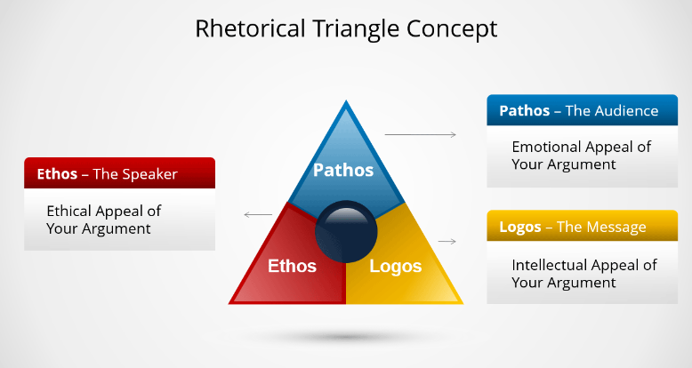

Rhetorical devices

Rhetoric in types of writing like narrative writing and poetry often relies on linguistic tools like figurative language and well-known figures of speech. These tools are known as rhetorical devices. Through a rhetorical device, you can make your argument feel more pressing, make it stick in listeners’ and/or readers’ minds, enable them to empathize with you or your characters, and drive them to think differently about the issue you are presenting.

There are lots of different rhetorical devices you can employ in your writing. Here are a few common ones:

Hyperbole: is an extreme exaggeration meant to highlight the issue presented:

“I deal with thousands of angry customers every day.”

With hyperbole, both the speaker and the listener know it is an exaggeration. The goal is to demonstrate how an issue compares to the norm or to other issues by positioning it as wildly outside the norm.

Meiosis: The reverse of hyperbole, meiosis emphasizes how far outside the norm an issue is through extreme understatement:

“Compared to others in the area, our school was empty.”

Epistrophe: is the repetition of a word through successive phrases, clauses, or sentences for the purpose of emphasizing it as a concept. Typically, [parallelism](https://www.grammarly.com/blog/parallelism/) is employed to underscore this repetition and give the speech a poetic quality. Abraham Lincoln used epistrophe in this famous excerpt from the Gettysburg Address:

“. . . government of the people, by the people, for the people, shall not perish from the earth.”

Metaphor: is a type of figurative language that compares two topics by claiming that one literally is the other:

“My mother’s cooking is heaven on earth.”

Chiasmus: is the repetition of a sentence with the word order switched around. Perhaps the most famous example of chiasmus comes from President John F. Kennedy:

“Ask not what your country can do for you—ask what you can do for your country.”

The liberal arts denote the seven branches of knowledge that initiate the young into a life of learning.

1. Logic- art of thinking.
2. Grammar- art of inventing and combining symbols.
3. Rhetoric- art of communication.
4. Arithmetic- theory of number.
5. Music- application of the theory of number.
6. Geometry- theory of space.
7. Astronomy- application of the theory of space.

The “Trivium” comprises the logic, grammar, and rhetoric part.

The “Quadrivium” is made up of the arithmetic, music, geometry, and astronomy parts.

These arts of reading, writing, and reckoning have formed the traditional basis of liberal education, each constituting both a field of knowledge and the technique to acquire that knowledge.

A mastery of the liberal arts is widely recognized as the best preparation for work in professional schools, such as those of medicine, law, engineering, or theology.

Utilitarian arts- in academics- are considered things like carpentry, masonry, plumbing, salesmanship, printing, editing, banking, law, medicine, or the ‘care of souls.’

The seven ‘fine arts’- in academics- are considered things like architecture, instrumental music, sculpture, painting, literature, drama, and dance.

Modality in rhetoric refers to the degree of certainty, obligation, or necessity expressed in a statement.

Learning in the liberal arts is focused on personal growth rather than earning money. The learner, or "agent," initiates and benefits from this process, improving themselves through their studies. Unlike vocational fields where the work might lead to payment, in liberal arts, the student often pays for instruction, investing in their own development rather than working for external rewards.

There are three classifications of goods:

1. Valuable-these goods are both wanted by the consumer, and help increase the consumer’s intrinsic value
2. Useful-these goods are wanted because they enable the consumer to use it in acquiring other goods
3. Pleasurable- these good are desired only to be had- they give satisfaction to the consumer and nothing more

The liberal arts teach one how to live; they train the faculties and bring them to perfection; they enable a person to rise above his material environment to live an intellectual, a rational, and therefore a free life in gaining truth.

Each of the liberal arts is both a science and an art in the sense that in the province of each there is something to know (science) and something to do (art).

The trivium is the organon, or instrument, of all education at all levels because the arts of logic, grammar, and rhetoric are the arts of communication itself in that they govern the means of communication—namely, reading, writing, speaking, and listening.

Grammar is knowledge of the usage of language and consists of:

1. Trained reading.
2. Exposition.
3. Making complex topics easier to understand.
4. Understand the origins and historical development of words.
5. Describing or identifying the similarities and relationships between different concepts, objects, or experiences.
6. Analyzing and evaluating poetry.

If the reader or listener receives the same ideas and emotions that the writer or speaker wished to convey, he understands (although he may disagree); if he receives no ideas, he does not understand; if different ideas, he misunderstands.

The accrual of facts is mere information and is not worthy to be called education since it burdens the mind and dulls it instead of developing, enlightening, and refining. Even if one forgets many of the facts once learned and related, the mind retains the vigor and precision gained by its exercise upon them. It can do this, however, only by grappling with facts and ideas. Moreover, it is much easier to remember related ideas than dissimilar ideas.

The purpose of the trivium is the training of the mind for the study of substance and essence, which together constitute the totality of reality.

Metaphysics or ontology, the science of being, is concerned with reality, with the thing-as-it-exists.

As they relate to reality: logic is concerned with the thing-as-it-is-known, grammar is concerned with the thing-as-it-is-symbolized, and rhetoric is concerned with the thing-as-it-is-communicated.

Rhetoric is the master art of the trivium, for it presumes and makes use of grammar and logic; it is the art of communicating- through symbols- ideas about reality.

Where grammar concerns combining words for correct sentence formation, spelling concerns the arrangement of letters for correct word formation, and phonetics is concerned with combining sounds correctly for the formation of spoken words.

Rhetoric is responsible for the combining of sentences into paragraphs and whole compositions by encouraging the author to use unity, coherence, emphasis, and clarity in construction.

Logic means combining concepts into judgments and patterns of reasoning to reach truthful conclusions.

The adaptation of language to circumstance, which is a function of rhetoric, requires the choice of a certain style and diction in speaking to adults, of a different style in presenting scientific ideas to the general public, and of another in presenting them to a group of scientists.

Because the arts of language are normative, they are practical studies as contrasted with speculative. A speculative study is one that merely seeks to know—for example, astronomy. We can merely know about the heavenly bodies. We cannot influence their movements.

Correctness is the norm of phonetics, spelling, and grammar.

Effectiveness is the norm of rhetoric.

Truth is the norm of logic. Correctness in thinking is the normal means to reach truth, which is the conformity of thought with things as they are—with reality.

The function of language is to communicate thought, choice, and emotion.

All animals- including man- can communicate through some sort of vocalization. Only with humans can these vocalizations be crafted into sentences.

Two possible modes of communication through physical material or medium:

1. Imitation: an artificial likeness used to communicate.
2. Symbols: an arbitrary sign with a meaning connected to something experienced by the senses.

Symbols may derive meaning from nature or convention and can be temporary or permanent.

Special symbols are designed by experts to express with precision ideas in a special field of knowledge, for example: mathematics, chemistry, music. Such special languages are international and do not require translation, for their symbols are understood by people of all nationalities in their own language.

Every dead language, like Latin, was once a thriving, widely spoken language. Although it may no longer be spoken as a native language, it can still be useful for specific purposes like religious rituals or doctrine. In fact, its 'dead' status ensures that it remains unchanged and unambiguous, unlike living languages which evolve over time and can be interpreted in multiple ways. This means that a dead language is more likely to be understood consistently across different times and places.

Matter is defined as the first fundamental and purely probable belief of a physical essence; as such, it cannot actually exist without form, for it is not a body but a principle of a body, basically constituting it. Form is the first intrinsic and actual principle of a corporeal essence.

The matter of words in spoken language is the sound. This aspect of language is treated in phonetics. The matter of words in written language is the mark or notation. It is treated in orthography or spelling. The form of words is their meaning, and it is treated in semantics.

In the study of metaphysics and ontology, which explores the nature of existence, we can differentiate between two concepts: the individual and the essence. The individual refers to any physical entity that has existence, such as objects, beings, or substances. What's key about individuals is that they possess a unique identity, meaning each one exists distinctly, is itself and not something else, and has an inherent singularity that sets it apart from others.

Essence is that in an individual which makes it like others in its class.

Inasmuch as every individual belongs to a class, which in turn belongs to a wider class, we distinguish these classes as species and genus. A species is a class made up of individuals that have in common the same specific essence or nature.

A genus is a wider class made up of two or more different species that have in common the same generic essence or nature.

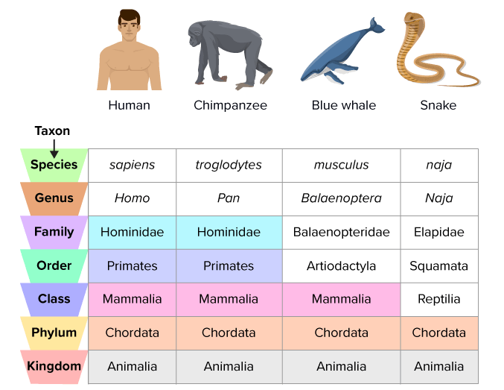

An aggregate or group of individuals must be clearly distinguished from a species or a genus. An aggregate is merely a particular group of individuals, such as the trees in Central Park, the inhabitants of California, the Philadelphia Orchestra, the items on a desk, the furniture in a house.

Language can symbolize an individual or an aggregate by either a proper name or a particular or empirical description.

A common name or a general description should capture the fundamental characteristics or nature of a category, even if what it describes doesn't necessarily exist in reality.

Deriving concepts from experience involves several stages, explored in psychology. We observe, reflect, abstract, and categorize, forming universal ideas that help us understand the world.

The external senses, which include sight, hearing, touch, smell, and taste, function by interacting with an object that is directly in front of us, creating a perception of it. On the other hand, the internal senses, mainly imagination, generate a mental representation or image of the specific object we have sensed. This mental image is stored in our memory and can be recalled voluntarily, even when the actual object is not present.

A percept is the mental result or representation of perceiving something through the senses. It's essentially how the brain interprets sensory information to form an understanding or awareness of the environment.

The imagination serves as the intersection where sensory experiences and intellectual understanding come together. Within the imagination, from the mental images or phantasms it creates, the intellect extracts the common and essential qualities shared by phantasms of alike objects (such as trees or chairs). These extracted qualities define the essence of each object, determining what fundamentally constitutes a tree as a tree or a chair as a chair.

A general concept is a broad idea that exists solely within the mind, yet its basis is rooted in the external essence of individuals, which defines their nature or type. This essence, existing outside the mind, is what makes each thing uniquely what it is.

Only humans possess the ability for intellectual abstraction, meaning only humans can develop general or universal ideas. While animals also have external and internal senses, often sharper than humans', they lack rational capabilities such as intellect, intellectual memory, and free will. As a result, animals cannot achieve progress or culture.

Once the human intellect creates symbols from reality, those symbols or words can be manipulated and catalogued to increase our understanding of reality.

Aristotle's ten categories are a framework for classifying everything that can be spoken about.

1. Substance- anything that “exits unto itself”.
2. Quantity- when a thing gives itself parts distinct from other parts.
3. Quality- when a thing determines its nature or form.
4. Relation- references how one thing connects to another.
5. Action- the exercise of a thing to produce some effect.
6. Passion- how one thing reacts to an effect produced by something else.
7. When- the position of a thing relating to events outside itself.
8. Where- the position of a thing related to things around it.
9. Posture- the relative position of a thing’s parts from its other parts.
10. Habiliment- consists of clothing, ornamentation, or other manner of external expression.

Those ten categories can be fit into another 3 subcategories based on what they predicate about the subject:

1. Substance: This remains its own category due to its fundamental nature. It refers to what a thing is, encompassing individual entities (primary substances) that exist in their own right and the species or genera (secondary substances) to which these entities belong. Substance is the most basic and essential category, serving as the subject to which other categories can be applied.
2. Quantity and Quality: These two categories often go hand-in-hand because they both describe properties or attributes of substances. Quantity refers to the measurable aspects of a substance (how much, how many), while Quality describes the characteristics that distinguish a substance and determine its nature (what kind, which traits). Together, these categories help to describe what a substance is like in more detail, addressing its attributes and dimensions.
3. Relation, Place, Time, Position, State, Action, and Affection: These categories can be grouped together because they all relate to the ways in which substances interact with each other and with the world. Relation covers how substances are in reference to one another. Place and Time specify the 'where' and 'when' of substances. Position and State describe the condition or arrangement of substances. Finally, Action and Affection are about the dynamics of change, detailing what a substance does (Action) and what happens to it (Affection).

Seven important definitions exist in consideration of language and reality:

1. The essence of something is what makes it itself, and without it, it wouldn't be what it is.
2. Nature is seen as the essence that drives activity.
3. An individual consists of a common essence that links it to its group, counted matter that makes it unique, and coincidences like shape or color that differentiate it from others in the group. While all members of a species share the same essence, it's their unique matter and distinguishing features that make each individual distinct, even among seemingly identical items.
4. A percept is how we sense and understand something real when it's directly in front of us.
5. A phantasm is the mental picture we have of something real when it's not present.
6. A general concept is our understanding of what something essentially is.
7. An empirical concept is how we understand specific things indirectly through mental images, since we can't grasp them directly with our intellect due to their material nature. The exception is our own mind, which can understand itself directly.

In a natural object the following are similar but distinct: substance, essence, nature, form, species.

A construct may be analyzed into its components by showing in what categories its essential meanings lie.

Language has logical and psychological meanings. A word like “house” will elicit a more formal, less emotional, mental image. The word “home” will elicit a more emotional and psychological connection.

The logical or intellectual dimension of a word is its thought content, which may be expressed in its definition, given in the dictionary. In rhetoric this is called the meaning of the word.

Pedantic or pompous styles of writing are often psychologically displeasing. Mostly, this can be due to the fact that it takes far more processing to decipher this type of language over simplified meaning. Think of someone like Shakespeare to get an idea of this type of writing.

Idiomatic language refers to expressions, words, or phrases that have a meaning which is not predictable from the usual meanings of its basic elements or from the general grammatical rules of a language. In other words, an idiom's symbolic meaning is separate from the precise meaning.

Allusions are brief references to familiar phrases or passages that authors assume readers will recognize. This language of allusion serves as a concise shortcut, connecting people across time and shared experiences, conveying complex ideas and emotions in just a few words.

A word's ambiguity can come from three sources. First, its meaning can change over time, accumulating multiple definitions. Second, the way we use language can lead to multiple interpretations. Finally, the idea or concept a word represents can be open to interpretation. These factors make language complex and nuanced, and can affect how we understand words and meanings.

First imposition: a term used to describe the initial thesis or main argument that a rhetor (speaker or writer) presents before developing and supporting it further.

Zero imposition: when someone talks or writes in a way that makes their request or statement seem less demanding.

Second imposition: using a word to talk about the word itself, focusing on both its sound and meaning, is specific to grammar. Without knowing a word's meaning, we can't organize it grammatically. So, grammar studies how words are used and understood in this special way.

First intention: refers to the direct, initial meaning or purpose of a statement or argument, focusing on the primary, straightforward interpretation without delving into deeper, more abstract, or second-order meanings.

Second intention: in rhetoric and philosophy refers to the more abstract, secondary, or indirect meanings and interpretations of words or concepts, beyond their immediate, literal sense ("first intention"). It involves understanding how terms are used to refer to ideas or categories rather than to direct, tangible objects or actions. This can include the way we categorize or conceptualize things in our minds, as opposed to how we directly perceive or talk about them.

The primary purpose of a proper name is to designate a particular individual or aggregate; yet a proper name is sometimes ambiguous in designation because the same name has been given to more than one individual or aggregate within the same species.

Irony is the use of words to convey a meaning just the contrary of the one normally conveyed by the words.

Metaphor is the use of a word or a phrase to evoke simultaneously two images, one literal and the other figurative. (It is deliberate ambiguity of images.) Example: "He was a shining light in a dark room."

A dead metaphor is a metaphor that has been used so often and has become so common that it has lost its original metaphorical meaning and is now taken literally. It's a figure of speech which has become so familiar through repeated use that its original sense of comparison is no longer vivid.

Pun: the use of a word that has two or more meanings.

Logic is concerned only with operations of the intellect, with rational cognition, not with choice nor with the emotions.

Grammar provides a means to convey various mental and emotional states - thoughts, desires, feelings, and intentions - through different sentence types, including declarations, inquiries, expressions of desire, supplications, directives, and outbursts of emotion.

Rhetoric involves selecting the most effective grammatical expression among multiple options to convey an idea, considering the specific context and audience to ensure clear and impactful communication.

Being refers either to the whole individual or the essence which is common to the individuals of either a species or genus.

General grammar focuses on how words connect to ideas and realities, while specific grammars, like those for English, Latin, French, or Spanish, primarily deal with how words relate to each other. General grammar is more philosophical because it is more directly related to logic and to metaphysics or ontology (the study of existence, reality, and how we categorize and understand the world).

Categorematic words are words with independent meanings that contribute to the overall meaning of a sentence. Examples include nouns, verbs, adjectives, and adverbs, which are essential words that help us communicate effectively.

Syncategorematic words are words that don't have meaning on their own, but help clarify or connect other words to create a meaningful phrase. Examples include words like 'and', 'the', and 'or', which don't have independent meaning but help shape the meaning of a sentence. There are two main types: connectives (like 'and' and 'but') and definitives (like 'the' and 'a').

Substantives- a term used to refer to any word, phrase, or clause that functions as a noun or noun equivalent. Substantives are the "substance" of the sentence that can act as the subject, object, or complement, carrying the main nominal meaning within a sentence or clause. The role of substantives is foundational in sentence structure because they can perform the core functions that are typically associated with nouns.

Attributives- are words or phrases that modify or describe nouns, providing more information about the noun's qualities, quantities, or characteristics. They essentially attribute certain properties to nouns. Attributives can be adjectives, noun adjuncts (nouns that modify other nouns), or even phrases that serve a similar descriptive function.

Interjections are included as a “part of speech” even though they don’t truly fit because:

1. They cannot be assimilated into the structure of a sentence.
2. They express emotion, not thought, and so have no logical significance.

Noun: refers to a word that names a person, place, thing, or idea. Nouns can serve as the subject or object of a sentence, and they can be classified in several ways, including proper nouns (which name specific individuals, places, or organizations and are usually capitalized, like "London" or "Nike") and common nouns (which refer to general items or concepts, like "city" or "shoe"). Nouns can also be categorized based on their ability to count (countable nouns like "apple" can have a plural form, whereas uncountable nouns like "music" cannot be counted and don’t typically have a plural form).

Pronoun: a word used to replace a noun or a noun phrase, helping to avoid repetition and make sentences smoother. Pronouns can refer to individuals, groups of people, objects, or concepts and vary in form to reflect number (singular or plural), person (first, second, or third), gender (in some languages), and case (subjective, objective, or possessive).

In rhetoric, abstraction refers to the process or result of generalizing ideas or concepts away from specific instances or concrete examples to consider broader, less detailed aspects. It involves discussing ideas, qualities, or characteristics without grounding them in specific, tangible examples. Abstractions allow speakers or writers to discuss complex or broad topics in a way that can be universally applicable or understood, but it may also make the material more challenging for some audiences to grasp fully due to the lack of concrete details or examples.

The human power to abstract and to study a selected aspect of reality is the measure of intellectual progress which contrasts strikingly with the utter absence of such progress among irrational animals despite their wonderful instincts, which are often superior to the instincts of man.

A substantive naming a species or a genus has number; that is, it may be either singular or plural because it may designate either one or more than one of the individuals that constitute the species or the genus. Such a substantive is either a common name or a general description.

A substantive may be masculine, feminine, neuter, or common.

Person: this is a characteristic much more important to pronouns than to nouns. It has its natural origin in conversation, for first person is the speaker; second person is the one spoken to; and third person, the one spoken of.

The relative pronoun simultaneously performs three functions: (1) It stands for a noun. (2) It connects clauses. (3) It subordinates one clause to another. Example: The book that I borrowed from the library is overdue.

Case shows the relationship of a noun or a pronoun to other words in the sentence. Four cases of substantives are distinguished in general grammar, for these are the relationships necessary in every language, although not in every sentence.

Modern English grammar distinguishes only *three* cases: nominative, genitive (aka possessive), and accusative.

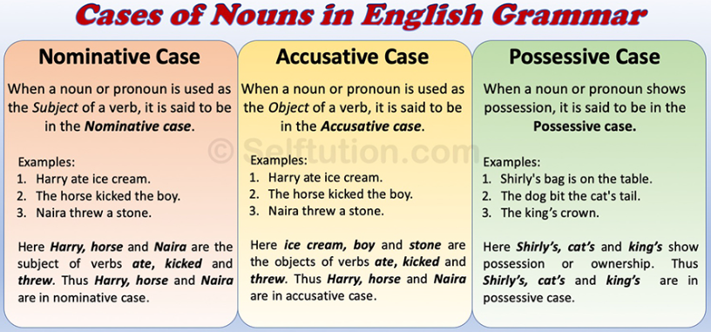

Substantives, such as nouns and pronouns, are versatile words that can play many roles in a sentence. They can serve as the main subject, describe the subject, receive the action of a verb, or indirectly receive the action. They can also complete the meaning of a verb or object, follow a preposition, show possession, add extra information, address someone directly, or explain/ rename another substantive. In essence, substantives are essential words that help convey meaning and structure in language, and their various functions enable us to express complex ideas and relationships.

Attributives are words which express the accidents that exist in substance. Primary attributives include verbs, verbals, and adjectives.

Verbs: express an attribute with a notion of time (some kind of change taking place), tense (the relation between the time of the act spoken of and the time of speaking of it), mode (indicative- with certainty, or potential- possibly) or mood, and it also asserts (expresses a complete thought).

The three grammatical forms:

* Indicative: expresses relations that are matter of fact
* Subjunctive: can express potential, interrogative, or eager relations
* Imperative: expresses a command

Transitive verbs: expresses actions that begin with an agent and goes across to an object. Example: The leaves fell gently to the ground as autumn arrived.

A transitive verb always requires a complement, that is, a word which completes the meaning of the predicate. Example: He bought a new car with the latest technology features.

Intransitive verb: when a verb's action doesn't "transfer" from the doer to a receiver. Intransitive verbs often describe actions that can't physically affect something else, or they simply indicate a state of being, presence, or occurrence. Example: The sun rises in the east.

Copula: a word or phrase that links the subject of a sentence to a subject complement. Example: The sky is blue.

A copulative verb, also known as a linking verb, is a type of verb that connects the subject of a sentence to a subject complement. The subject complement can be a noun, pronoun, or adjective that describes or identifies the subject. The purpose of a copulative verb is not to indicate action but rather to link the subject with further information about the subject. Example: She seems very happy with the surprise party we organized for her.

Pseudocopula: refers to a word or phrase that functions similarly to a copula or linking verb but doesn't fit the traditional definition of a copula. Pseudocopulas link the subject of a sentence to a complement or an adjective, much like copulas do, but they often imply a more dynamic or specific relationship than the static being or existence implied by true copulas such as "is" or "are." Example: The milk has gone sour in the refrigerator overnight.

Verbal: words derived from verbs that function in a sentence as nouns, adjectives, or adverbs, rather than as verbs. They come in three forms: gerunds, participles, and infinitives.

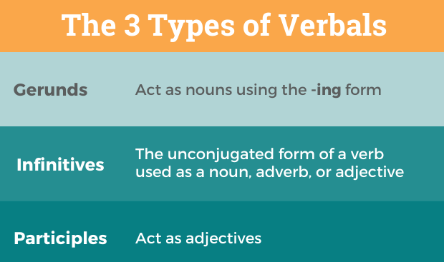

Adjectives: adjectives are words that modify, or describe, nouns. Example: They live in a beautiful house.

Adverb: a word that modifies or describes a verb, an adjective, another adverb, or even a whole sentence. Adverbs often end in “-ly”, but some look exactly the same as their adjective counterparts. Example: The race finished too quickly.

A definitive is a word which, when associated to a common name, is capable of singling out an individual or a group of individuals from the whole class designated by the common name. Example: Can you pass me the salt?

In grammar, a determiner is a word or a group of words that introduces a noun, indicating reference to something specific or nonspecific. Determiners are used before nouns to clarify what the noun refers to. They provide context to the noun, often in terms of definiteness, quantity, possession, or another relationship. Example: Can you pass me a book?

Article: a type of determiner that precedes a noun to indicate the specificity of the noun's referent. Articles are part of the broader category of determiners, which also includes numbers, possessive pronouns, and other words that specify or quantify nouns. There are two types:

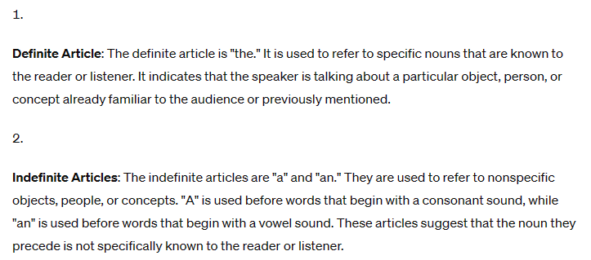

Pronominal: resembling a pronoun in identifying or specifying without describing. Example: This dog is his.

A definitive modifier helps to clarify which person or thing is being referred to.



An attributive modifier provides additional information about someone or something who has already been identified.



Connectives are like glue in a sentence. They include words like prepositions (such as "in" and "on"), conjunctions (like "and" and "but"), and a basic linking verb known as the pure copula (often "is" or "are"). These words help stick the main parts of a sentence together so that it expresses a complete idea clearly.

A preposition is a word used to express the relationship between a noun or pronoun and other words in a sentence. It can indicate location ("in," "at," "on"), direction ("to," "from"), time ("before," "after"), and many other relationships. Prepositions are essential for constructing sentences that make sense because they provide context that clarifies how different parts of a sentence are connected. For example, in the sentence "The book is on the table," "on" is the preposition that tells us where the book is in relation to the table.

The term "genitive" refers to a grammatical case that primarily expresses possession or ownership, but it can also denote various other relationships between words in a sentence. In English, the genitive case is often indicated by adding an apostrophe and an "s" to the end of a noun (for example, "the cat's whiskers" means the whiskers belonging to the cat) or by using the word "of" (as in "the sound of the music").

The dative is a grammatical case used in some languages to indicate the indirect object of a verb. The indirect object is typically the recipient or beneficiary of the action. In English, we don't have a distinct dative case in the form of specific word endings, but we do use word order and prepositions like "to" and "for" to express the same idea. For example, in the sentence "I gave the book to Mary," "to Mary" is the indirect object, showing who received the book.

Prepositions are often used to express the genitive (of the children) and dative (to the children) relationships of nouns.

A conjunction is a word that joins together words, phrases, or clauses in a sentence. Conjunctions are essential for creating complex sentences and expressing relationships between ideas.

Coordinating Conjunctions link elements of equal grammatical importance in a sentence. The most common ones are "and," "but," "or," "nor," "for," "so," and "yet." For example, in the sentence "I wanted to go for a walk, but it started raining," "but" is a coordinating conjunction connecting two independent clauses.

Subordinating Conjunctions introduce a dependent (or subordinate) clause, indicating its relationship to the main clause. Examples include "because," "although," "since," "unless," and "while." In the sentence "I stayed home because it was raining," "because" introduces the reason for staying home, linking it to the main clause.

Correlative Conjunctions work in pairs to join together parts of a sentence, such as "either...or," "neither...nor," "not only...but also." An example would be "You can either have ice cream or cake," where "either...or" connects the two options.

Use a semicolon or a period between clauses or sentences conjoined by a conjunctive adverb, for example: It rained; therefore, we postponed the picnic.

Use either a comma or no punctuation where a dependent clause is subjoined to an independent clause by an adverbial conjunction, for example: Because it rained, we postponed the picnic.

Simple and progressive (also known as continuous) verb forms represent different aspects of verbs in English, highlighting how actions relate to time. Understanding these forms helps convey the nature of actions—whether they are habitual, completed, or ongoing.

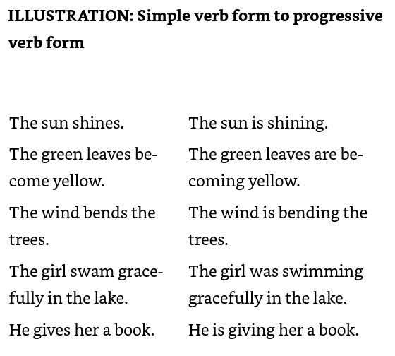

The progressive form shows that when the basic linking verb "is" changes form, it does three important things in grammar: (1) it makes a statement, (2) it shows how the speaker feels about the action, and (3) it tells us when the action happens.

A basic syntactical analysis of a declarative sentence might go like this:

"The quick brown fox, surprisingly agile, jumps over the lazy dog in the garden."

* A simple subject- “The quick brown fox” is the subject and the simple subject is “fox”
* A simple predicate- “jumps”
* A clause- “over the lazy dog in the garden”
* A modifier of a modifier- “surprisingly” is the adverb modifying “agile”, which modifies “fox”
* A connective to join the parts together- “over” links the action to the parts it relates to

The fundamental function of grammar is to establish laws for relating symbols so as to express thought. A sentence expresses a thought, a relation of ideas, in a declaration, a question, a command, a wish, a prayer, or an exclamation.

A form word is a small word that helps a sentence work properly but doesn't have much meaning by itself. These words include "and," "the," "is," and "she." They help connect the bigger, more meaningful words together in a sentence.

An inflection is when you change a word slightly to show different meanings, like making a word plural ("cat" to "cats") or showing action happened in the past ("jump" to "jumped"). It's like adding a little twist to a word to tell more about it.

The rules for relating symbols govern three grammatical operations: substituting equivalent symbols, combining symbols, and separating symbols.

For substituting using expansion:

* You can replace proper names with detailed descriptions based on facts (empirical description)
* Common names can be replaced with general descriptions that apply to a category (general description)
* Single words can be expanded into phrases for more clarity
* Phrases can be expanded into sentences or even a group of sentences for further explanation and detail

For substituting using contraction:

* You can potentially condense empirical descriptions into concise proper names
* General descriptions can be condensed into common names
* Sentences can be condensed into shorter phrases
* Phrases can be condensed into single words

For combining

* Form words (such as conjunctions and prepositions) to connect phrases and clauses
* Inflections (like suffixes and prefixes) to modify words and indicate grammatical relationships
* Word order to convey meaning and emphasis
* Stress (emphasizing certain words or syllables) to convey importance or contrast
* Intonation (the rise and fall of pitch when speaking) to convey attitude, questions, or statements

Marks of punctuation do for written language what phrasing, stress, and some forms of intonation, such as raising the voice for a question, do for spoken language.

While words across languages can be equivalent in their basic meanings or functions, they often carry different weights, colors, and textures in the minds of their speakers. This distinction is crucial for translators, writers, and communicators who navigate across cultures, reminding us that language is not just a tool for conveying information but also a rich tapestry of human experience and cultural identity.

An "empirical term" is one that relates to observable reality, referring directly to things that can be experienced through the senses. It contrasts with abstract terms, which may refer to concepts or qualities not directly tied to physical or observable entities.

Proper names and empirical descriptions serve as bridges between the abstract symbols of language and the concrete entities of the physical world. They allow us to communicate about specific things in our environment, ensuring our discussions are grounded in shared reality. This understanding is foundational in both everyday communication and in more structured domains like logic, science, and philosophy, where clarity about what we're referring to is essential.

When we talk about words being contradictory, it means one word says something is there, and the other says it's not there. A "positive" word tells us about something that exists or is happening. A "negative" word tells us about something that doesn't exist or isn't happening.

A "privative term" is a special kind of word that tells us something is missing. It's used when something naturally should have a feature, but that feature is not there. For example, if we say "blind" about a person, we're using a privative term because being able to see is a natural feature for people, but in this case, it's missing.

An "abstract term" is a word that stands for an idea or concept taken from real-life things but thought about separately from them. It's like when we think about the idea of "beauty" or "strength" on their own, without connecting them to a specific person or object. These terms help us focus on certain qualities or ideas as if they were things we can talk about all by themselves.

A collective term is one that can be applied only to a group as a group but not to the members of the group taken singly.

A distributive term is one that can be applied to individual members of a group taken singly. For example, man is applicable both to every individual man and to the species man.

The ten categories of being, also known as Aristotle's categories, are a foundational concept in classical philosophy, outlining different ways that a thing can be said to be. These categories are meant to describe how objects and subjects can exist and be understood. Here they are:

1. Substance (Substantia): This refers to what a thing is. Substance is the essence or the nature of beings, making them what they uniquely are. For example, a specific person or a specific tree.
2. Quantity (Quantitas): This pertains to the measurable aspects of a being, such as length, volume, and number. It answers questions like "How much?" or "How many?"
3. Quality (Qualitas): This category describes the characteristics or attributes that a being possesses, such as color, shape, or any other trait that describes how a being is.
4. Relation (Relatio): This is about how one being may be related to another. Relations can include concepts like "bigger than," "father of," or "belonging to."
5. Place (Ubi): This answers the question of where a being is located. It refers to the physical location or position in space of a being.
6. Time (Quando): This category refers to when something occurs or exists. It's concerned with the temporal aspects of being, such as age or time of day.
7. Position (Situs): This pertains to the posture or arrangement in space of a being, like sitting, standing, or lying down.
8. State (Habitus): This describes the condition or status of a being, especially in relation to its external circumstances or attire, such as being dressed in a certain way or being armed.
9. Action (Actio): This is about what a being does or can do. It involves activities or processes that a being initiates or performs.
10. Affection (Passio): Also known as "being acted upon" or "passion," it refers to what happens to a being or how it is affected by an action.

The basis of the difference among Aristotle's ten categories of being lies in the various aspects or dimensions of reality that they each capture, essentially categorizing all possible ways in which we can talk about the existence of things. These categories are designed to reflect the fundamental ways in which objects and their attributes manifest in the world, as well as how they relate to human perception and understanding. Here's a closer look at the distinctions:

1. Substance is the most fundamental category, concerning what things are in their essence. It's about identifying entities in their most basic form, separate from their qualities or quantities.
2. Quantity and Quality represent two fundamentally different aspects of being. Quantity refers to the measurable properties of entities, such as size or number, while Quality refers to the descriptive characteristics that differentiate things, like color or texture.
3. Relation introduces the concept of how entities can be understood in connection with one another, which is distinct from the intrinsic properties captured by Quantity and Quality.
4. Place and Time address the spatial and temporal dimensions of existence, respectively, highlighting the importance of when and where in understanding the being of objects.
5. Position and State describe conditions of entities but from different angles. Position is about the physical arrangement or posture of something, while State refers to a broader condition or situation of a being, often relating to its external circumstances.
6. Action and Affection (or being acted upon) focus on the dynamic aspects of being, distinguishing between the activities or operations that beings can initiate (Action) and the experiences or changes that they undergo as a result of external forces (Affection).

The concepts of extension and intention (or comprehension) relate to how we understand and classify terms, playing a crucial role in logic and philosophy.

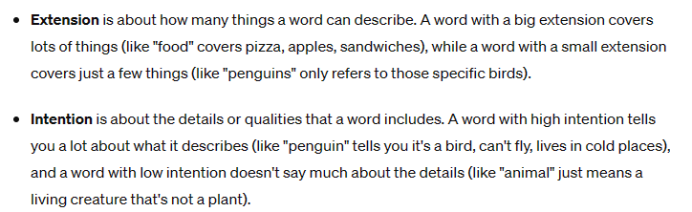

The Tree of Porphyry: a fundamental tool in medieval scholastic philosophy, serving as an educational tool for understanding and teaching the concepts of substance and accidents (the essential and non-essential attributes of a thing), as well as the hierarchical organization of reality, from the most general to the most specific.

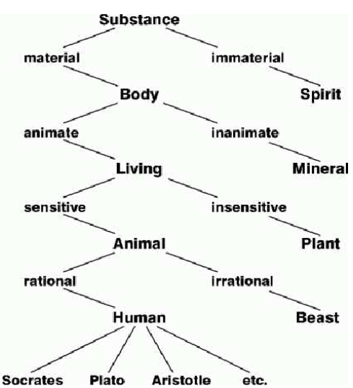

Some of the concepts in the illustration are:

Substance (the most general category): At the top of the tree, you have the most general category called "Substance," which represents everything that exists in the broadest sense. It's divided into two main subcategories:

* Material Substance: Things that have a physical form, like animals, plants, and inanimate objects
* Immaterial Substance: Things that exist but don't have a physical form, like the soul or mind (in philosophical contexts)

Material Substance: This category is further divided into living and non-living entities. Living entities (or beings) include plants, animals, and humans, while non-living entities include things like water, rocks, and air.

Living Beings: Living beings are categorized into plants, animals, and humans based on their ability to sense and move, and their level of intelligence or rationality.

* Plants: Defined by their ability to grow and reproduce but lack sensation and movement.
* Animals: Capable of sensation and movement but lack rationality.
* Humans: Possess growth, reproduction, sensation, movement, and rationality.

Further Subdivisions: Each of these categories can be further subdivided. For example, animals can be divided into different species based on specific characteristics, like the ability to fly or live underwater. Similarly, plants can be categorized into trees, shrubs, and herbs based on their size and structure.

Definition usually means a general description and comes in two types:

1. Logical definition: when you define something logically, you explain what group it belongs to and what makes it different from other members of that group.
2. Distinctive definition: explaining something by describing a unique feature or characteristic it has, even if that feature isn't the main thing that defines it.

Some other definitions are:

* A causal definition explains something by telling you why or how it came to be
* A descriptive definition simply lists the features that help you identify something
* Defining by example means showing specific instances or examples instead of directly explaining what something is
* A grammatical or rhetorical definition focuses on clarifying which word or phrase is being talked about, rather than explaining what that word or phrase means
* A definition by etymology explains a word by tracing its origins or history
* A definition by synonyms uses words with similar meanings to explain a term
* An arbitrary definition involves words that don't have a universally agreed-upon meaning. These are significant words that people understand in various ways, and even a dictionary might not provide a clear, practical definition

A good definition should be convertible to a subject, species, or term, positively stated, clear and concise, free from circular definitions by avoiding the same root word, and consistent in grammatical structure. By following these guidelines, definitions can be precise, unambiguous, and helpful for understanding the concept or term being defined.

The concept of "logical division" refers to the process of breaking down a broad or general category (a genus) into its more specific subcategories (species). The purpose of logical division is to organize knowledge and understanding in a structured, hierarchical manner. By breaking down a broad category into its more specific components, we can better comprehend the relationships and distinctions between the different elements within a larger system or classification. This process of logical division is commonly used in various fields, such as biology, taxonomy, philosophy, and even in the organization of information and knowledge more broadly.

While logical division involves breaking down a genus into its constituent species based on qualitative, essential characteristics, quantitative division refers to the division of a whole into parts based on quantitative, numerical values.

In rhetoric, physical division is a technique used to divide a whole into its constituent parts to better understand, describe, or analyze it. This technique is essential in descriptive writing, scientific explanation, and technical communication, helping to clarify complex concepts, identify relationships between parts, and provide detailed descriptions.

Virtual or functional division is a conceptual form of division that does not involve the physical separation of a whole, but rather the division of a whole into distinct functional or operational parts. Virtual or functional division is often used in the design, organization, and management of complex systems, where the focus is on the efficient division of labor, the coordination of interdependent components, and the optimization of overall system performance.

Metaphysical division refers to the conceptual division or classification of reality, existence, or the nature of being itself, based on philosophical and metaphysical principles. Metaphysical division is concerned with the most fundamental questions about the nature of existence, knowledge, and reality, and it often involves complex and speculative philosophical debates.

Metaphysical division is concerned with the most fundamental questions about the nature of existence, knowledge, and reality, and it often involves complex and speculative philosophical debates. Verbal division is an essential tool in various fields, including philosophy, science, education, and everyday communication, as it allows for the clear articulation and shared understanding of concepts, ideas, and knowledge.

Logical division is the division of a genus (a broader category) into its constituent species (more specific subcategories). It can further be broken down into logical whole, the basis of division, and dividing members.

Dichotomy is defined as division according to contradiction.

In the context of rhetoric, positive division refers to a rhetorical technique where the speaker or writer divides a topic or concept into its positive or affirmative aspects.

Subdivision is a more granular level of division that builds on a preceding broader division, and it aims to maintain a consistent, well-structured categorization of the overall topic or concept.

In co-division, you take the same overarching topic and divide it up in multiple ways, using different criteria or principles for each division. The divisions are independent of each other, but they all apply to the same core subject.

A proposition asserts a relationship between the subject, the copula (linking verb), and the predicate. It's a way of making a statement that can be evaluated as true or false.

In rhetoric, modal propositions specify the manner or mode of truth, using verbs like "can", "may", "must", and "should" to introduce nuances like ability, permission, and possibility. This device allows for more subtle and thoughtful communication, acknowledging complexity and ambiguity, and enabling more sophisticated arguments and descriptions. The key aspects of a modal proposition are:

* Modality - This refers to the "mode" or way in which the proposition is presented. Common modal terms include:
  + Necessary - "It must be the case that..."
  + Possible - "It may be the case that..."
  + Contingent - "It could be the case that..."
  + Impossible - "It cannot be the case that..."
* Subject and Predicate - Like a regular proposition, a modal proposition still has a subject and a predicate
* Evaluation - Modal propositions are evaluated based on the modal qualifier, rather than just being true or false. The proposition is assessed in terms of whether it is necessary, possible, contingent, or impossible

In rhetoric, physical necessity refers to the use of natural laws to establish inevitable events or outcomes. This technique appeals to the audience's understanding of the natural world, establishing cause-and-effect relationships, explaining phenomena, and predicting outcomes. By citing physical necessity, rhetoricians build credibility, create a sense of urgency, and craft persuasive arguments, particularly in fields like science, philosophy, and politics.

Moral necessity is a normative necessity referring to a free agent. Because of free will, humans can act counter to these laws.

A contingent proposition is one where the relationship between the subject and predicate is possible, but not necessarily required or impossible. In other words, a contingent proposition describes a situation that:

* Is not absolutely necessary to be true.
* Is not absolutely impossible to be true.
* May depend on future events, actions, or our current knowledge.

In rhetoric, a categorical proposition is a statement that asserts a relationship between two terms without specifying the nature of that relationship. It states a fact or connection without elaboration, serving as a building block for further argumentation and exploration. Categorical propositions establish basic relationships and facts, conveying certainty and confidence, and can be used to define terms, classify objects, or identify correlations.

A simple proposition is one that asserts the relation of two terms and only two.

A compound proposition is one that relates at least three terms. A compound proposition may be either hypothetical or disjunctive. A hypothetical proposition asserts the dependence of one proposition on another. A disjunctive proposition asserts that of two or more suppositions, one is true.

A general proposition is one whose subject is a general term, referring to an essence, symbolized by a common name or a general description.

An empirical proposition is one whose subject is an empirical term, referring to an individual or an aggregate, symbolized by a proper name or an empirical description.

In rhetoric, a total proposition is a statement with a subject term used in its full extension, making a universal claim without exception. This type of proposition establishes broad principles, enables sweeping claims, and creates a sense of certainty. It's used to make statements like "All humans are mortal," where the subject term "humans" includes every single individual without limitation.

In rhetoric, a general proposition is a statement about a class or category, rather than specific individuals. It lacks quantity in the classical sense, making claims about the nature of a group or category as a whole, without specifying a exact number or amount. General propositions allow speakers to develop abstract ideas, make broad claims, and facilitate deductive reasoning, making them essential in rhetorical arguments.

A categorical proposition is a statement that makes a claim about all members of a category. The subject of the proposition is used in its full or complete meaning, so the quantity being referred to is the entire set or group.

In rhetoric, quantity only applies to empirical propositions with plural subjects, such as "Most humans are right-handed." General propositions about abstract concepts or categories, like "Justice is a virtue," don't have quantity. Understanding this distinction helps rhetoricians make accurate claims, avoid misleading statements, and construct sound arguments.

In rhetoric, a plural empirical proposition is "total" when the subject term includes every single member of the group, without exception. For example, "All humans are mortal" is a total proposition, while "Most humans are right-handed" is not. Total propositions enable speakers to make universal claims, develop broad principles, and establish a foundation for deductive reasoning, creating a sense of certainty and absoluteness.

In rhetoric, a "partial" proposition refers to a portion of a group or category, signaled by limiting words like "some" or "most". This differs from a "total" proposition, which includes every member of the group. Understanding this distinction is crucial for accurate and effective argumentation, as it clarifies the scope of claims and helps rhetoricians avoid generalizations and assumptions. By recognizing partial and total propositions, rhetoricians can make precise claims, avoid misleading statements, and develop sound arguments.

An affirmative proposition asserts that the subject (fully or partially) is part of the predicate.

A negative proposition asserts that the predicate is excluded from or does not apply to the subject.

Empirical statements require examining real-world facts and data, rather than being based solely on abstract reasoning or logical deduction. Their truth value is determined synthetically by observing and putting together the relevant evidence.

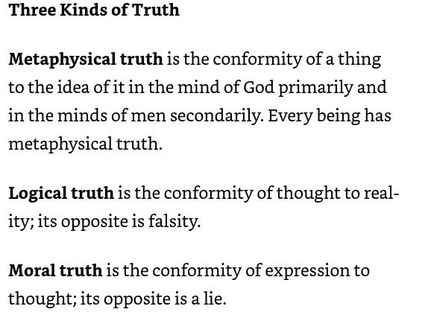

The concept of distribution:

1. Distributed Term: This happens when the term refers to every single element or instance it can possibly include. For example, in the statement "All dogs are mammals," the term "dogs" is distributed because it refers to all dogs, not just some.
2. Undistributed Term: This occurs when the term does not refer to all possible instances, but only a subset of them. For example, in the statement "Some dogs are black," the term "dogs" is undistributed because it only refers to some dogs, not all.

In logic, the predicables are a way to classify predicates based on how they relate to subjects in a proposition. For example, a predicate can tell us whether a subject belongs to a general category (genus), has special characteristics that distinguish it from others in that category (differentia), or has additional descriptive qualities (property or accident). This classification is similar to how in grammar, we analyze the structure of a sentence to understand the roles and relationships of words and phrases (like subjects, verbs, and objects).

In logic, categories are used to classify terms based on different kinds of being or existence, such as substance, quantity, quality, etc. This system of categorization is similar to how in grammar, words are classified into parts of speech like nouns, verbs, adjectives, etc., based on their function in a sentence.

While the predicables provide a useful framework for understanding how predicates can describe subjects, there are instances where this framework falls short, particularly when dealing with predicates that relate to broader or more distant categories than the subject directly belongs to. This limitation means that the predicables do not provide a completely exhaustive analysis of all possible types of predication.

Praedicamenta: When a predicate falls into the same category as the subject, it describes the subject either broadly or specifically. If it defines the subject as part of a genus, it's a broader description. If it specifies a species, the description is more specific.

To represent a logical idea, we need a declarative sentence that states a fact. This type of sentence can be either true or false, making it suitable for logical analysis. Sentences that are commands, wishes, questions, or exclamations don't qualify, as they express desires or actions rather than stating facts.

An empirical categorical proposition must be symbolized by a sentence whose subject is a proper name or an empirical description.

A sentence that represents an idea might be unclear. However, the idea itself cannot be unclear because the meaning or opinion that we intend to convey must be clear and singular.

The goal of translation is to convey the ideas represented by one language's symbols using the symbols of another language. If the ideas expressed in a scientific document available in four different languages weren't clear and the same across all languages, we would have four different documents, not just one.

Differences in style when expressing the same logical idea in the same language are caused by choosing different symbols. While these symbols may be logically similar, they differ in their emotional impact, rhythm, and structure—essentially, the words, phrases, and clauses chosen vary in how they feel and sound.

A simple declarative sentence may symbolize one simple proposition, two or more simple propositions, or a disjunctive proposition.

A complex statement can represent a single straightforward idea, multiple simple ideas, a conditional idea, or a logical argument.

Grammatical changes in a sentence often imply a logical statement. If a modifier isn't essential to identifying the subject, it adds a new idea or proposition. But if it's essential, it becomes a fundamental part of the subject, without suggesting a separate idea.

A syllogism is a logical argument that uses two statements to reach a conclusion. The statements share a common term, and a third term links them together. This type of reasoning is a basic building block of logic and was developed by Aristotle.

Here’s a basic example of a syllogism:

• All mammals are animals. (Major premise)

• All dogs are mammals. (Minor premise)

• Therefore, all dogs are animals. (Conclusion)

In this syllogism, the conclusion (that all dogs are animals) logically follows from the premises: the first stating a general rule about mammals and the second linking dogs specifically to mammals.

A disjunctive proposition is a type of logical statement that presents two or more options, where at least one must be true, but not necessarily all. It uses the connector "or" to link the different parts. The basic form of a disjunctive proposition is "A or B". This means either A is true, B is true, or both A and B are true. The emphasis is on the availability of multiple possibilities, without committing to just one unless further information is provided.

A compound sentence can represent either multiple simple ideas or a choice between options.

A declarative sentence that is grammatically correct but breaks the rules about using common or proper names and descriptions does not convey any clear idea because it lacks at least two logical terms needed to form a proposition.

In rhetoric, the term “invention” is the art of finding material for reasoning and discourse. “Disposition” means properly relating or putting some kind of order to that material.

The four types of relationships between propositions:

1. Conjunction: This is when you combine two statements using "and". Both statements must be true for the whole combined statement to be true. For example, if you say, "It is raining and it is cold outside," both "It is raining" and "It is cold outside" must be true.
2. Opposition: This describes different ways statements can contrast or conflict:

* Contradiction: This is when one statement completely opposes another, like saying "It is raining" and then saying "It is not raining."
* Contrariety: This is when two statements can't both be true at the same time, but they could both be false, such as "All birds are eagles" and "No birds are eagles."
* Subcontrariety: This is when two statements can both be true but can't both be false at the same time, like saying "Some birds are eagles" and "Some birds are not eagles."
* Subalternation: This happens when a general statement (like "All birds are animals") makes a specific statement (like "Some birds are animals") automatically true.

1. Eduction: This is about making new statements based on what you already know, through logical steps:

* Immediate Inference: Making a new statement directly from an existing one by slightly changing its form but keeping its meaning, such as turning "All birds are animals" into "No birds are non-animals."
* Obversion: Changing a statement into a different form by negating the quality and changing the predicate, like turning "All A are B" into "No A are non-B."

1. Syllogism: This involves drawing a conclusion from two related statements. It's like a mini-story where the end (the conclusion) logically follows from the beginning (the premises). For example:

* Major premise: "All mammals are warm-blooded."
* Minor premise: "All dogs are mammals."
* Conclusion: "Therefore, all dogs are warm-blooded."

The rules of conjunction deal with these three values.

Rule 1: A combination of statements is true only if every single statement in the combination is true. So, if all the statements are true individually, then when you combine them, that combined statement is also true.

Rule 2: A combination of statements is false if even one of the statements in the combination is false. This means that if any single statement is false, the whole combined statement becomes false.

Rule 3: A combination of statements is considered probable if at least one of the statements is probable (but not confirmed as true) and none of the statements are false. Therefore, if one statement is probable and all others are not false, then the entire combination is also probable.

The seven eductive forms in rhetoric are:

1. Definition - Explaining the meaning or essential nature of a term or concept.
2. Division - Breaking a whole into its parts or components.
3. Classification - Grouping things into categories based on shared characteristics.
4. Comparison - Examining the similarities and differences between two or more things.
5. Cause and Effect - Analyzing the reasons for or the consequences of something.
6. Analogy - Drawing a comparison between two things that share some similarities.
7. Exemplification - Using specific examples to illustrate or clarify a general statement or principle.

These eductive forms represent different ways of developing and supporting arguments or explanations in rhetoric and persuasive writing. They help the speaker or writer organize their ideas and present them in a logical, structured manner.

In rhetoric, the contrapositive is a logical argument or inference that draws a conclusion by negating both the antecedent and the consequent of a conditional statement.

The basic structure of a contrapositive argument is:

If A, then B. Therefore, if not B, then not A.

In rhetoric, the inverse is a logical argument that draws a conclusion by negating both the antecedent and the consequent of a conditional statement.

The basic structure of an inverse argument is:

If A, then B. Therefore, if not A, then not B.

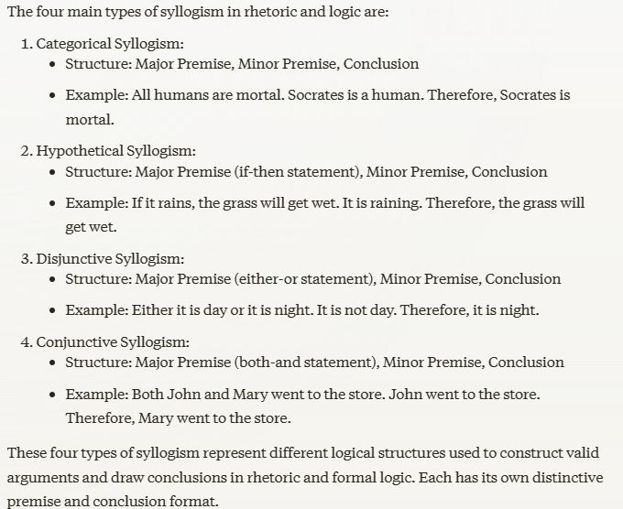

A syllogism is a logical argument that has two premises (starting statements) and a conclusion.

The two premises share a common term, and from those two premises, a new conclusion necessarily follows.

The syllogism itself is neither true nor false; it is valid or invalid. In a valid syllogism the truth or falsity of its propositions is interdependent and can be ascertained from the formula. An invalid syllogism is one whose conclusion does not follow from its premises.

These are the general rules for syllogisms:

1. A syllogism should have exactly three different terms.
2. A syllogism should have exactly three statements.
3. The middle term (the common link in the first two statements) must be used in a complete way in at least one of the initial statements.
4. A term cannot be more general in the conclusion than it was in its original statement.
5. You cannot derive a conclusion if both initial statements are negative.
6. If one of the initial statements is negative, then the conclusion must also be negative. To establish a negative conclusion, one of the statements must be negative.
7. You cannot derive a conclusion from two statements that are both uncertain or limited.
8. If one statement is limited, the conclusion must also be limited.
9. If one statement is uncertain, the conclusion must also be uncertain. For a definitive conclusion, both statements must be definitive.
10. If one or both statements are based on observation or experience, the conclusion will be based on observation or experience too.

An enthymeme is a shortened form of a syllogism where one part—either the major premise, the minor premise, or the conclusion—is left out. It still includes three terms and can be expanded back into a complete syllogism.

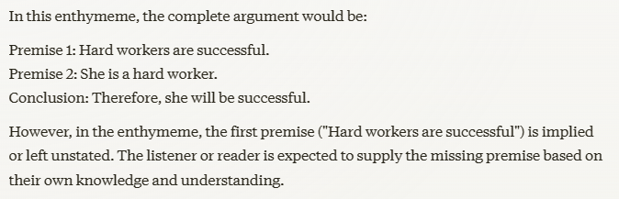

Rules for determining the validity of an enthymeme:

* Words like "because," "for," or "since" start a premise, which is a reason that leads to a conclusion. The other statement you see will be that conclusion.
* Words like "therefore," "consequently," or "accordingly" signal the conclusion itself.
* Words like "and" or "but" link two premises together, and suggest that the conclusion is missing and needs to be inferred.

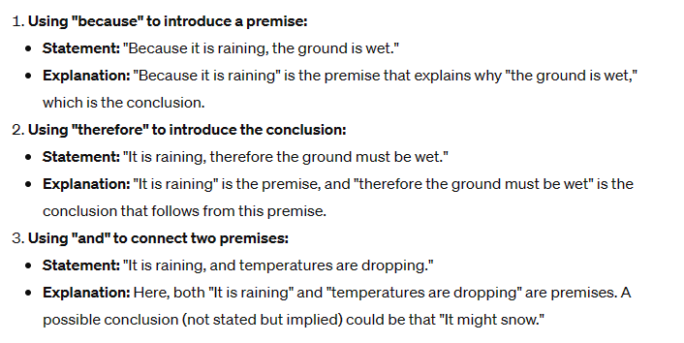

The enthymeme is the form of reasoning which we constantly employ in our thinking, conversation, and writing, and that which we should notice in our reading and listening.

The outline for a debate is like a chain of shortened arguments called enthymemes. Each main point presents a conclusion, and the supporting points, which start with "for," are the reasons backing it up. Once all the main points are made and summarized, the discussion progresses to the final conclusion.

A sorite is a form of argument where a series of statements are chained together. Each statement leads logically to the next, with the conclusion of one statement serving as the premise for the next. It builds up step by step until it reaches a final conclusion at the end. This kind of argument is sometimes also referred to as a "chain argument" because of how the statements are linked together like links in a chain.

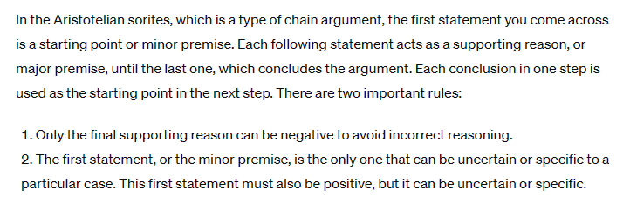

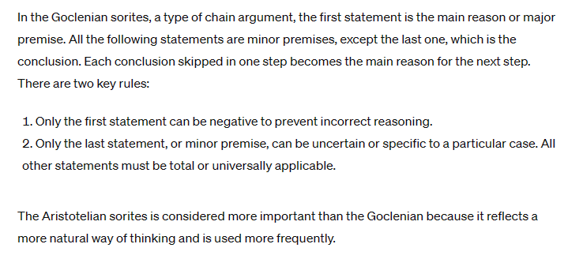

An epicheirema is a type of argument in which each premise is supported by its own additional reason or justification. Basically, it's like a regular argument but with extra steps that provide evidence or explanations for why each main point is true. This makes the overall argument stronger because each part is thoroughly backed up with more detailed information.

When we use analogy, we argue that because two things are alike in certain respects, they are likely to be similar in other ways as well.

Here's a breakdown of the key points:

1. Nature of Analogical Inference: Analogical inference produces conclusions that are probable, not certain. This means that while analogical reasoning can suggest likely outcomes or truths based on similarities, these conclusions aren't guaranteed to be correct.
2. Certainty and Analogy: If a conclusion derived from an analogy becomes certain, it's no longer considered an analogical argument. This happens when the similarities used in the analogy are so strong or conclusive that they prove a point definitively, moving beyond mere probability.
3. Usage in Various Fields: Analogies are widely used across different genres and fields, from poetry to scientific and literary prose. They help to explain complex ideas by relating them to familiar concepts.
4. Examples of Analogies: The text mentions "the ship of state" and "the body politic" as common analogies. These metaphors compare the governance of a state to steering a ship and running a government to managing a human body, respectively, helping to illustrate political theories through more tangible concepts.
5. Role in Scientific Discovery: In science, analogies have often guided researchers toward new discoveries. By comparing unknown phenomena with known entities, scientists can form hypotheses and explore new ideas.

The concept of "mediated opposition" in logic refers to a relationship between two propositions that indirectly oppose each other through a shared term.

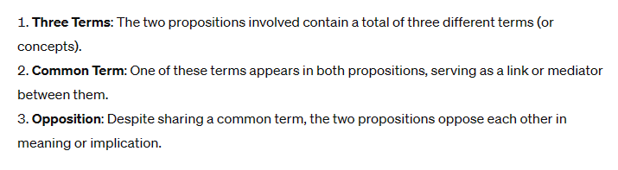

Empiricists suggests that in some syllogisms, you must know the conclusion beforehand to state the major premise, especially when the premise is just a list of observations. However, this isn't always the case, particularly when the major premise is a general statement. The truth of a general statement is understood through analyzing how its terms relate to each other, not by simply counting specific examples. Therefore, its validity doesn't rely on examining each individual instance but rather on understanding the deeper relationship between the concepts it involves. This kind of understanding is about the essence or nature of things (intension), not just about counting or measuring them (extension).

A valid syllogism is essentially a set of rules for reasoning. It tells you how to derive a conclusion based on the truth of certain premises or statements. Here’s how it works if the syllogism is valid:

1. If both premises (the statements you start with) are true, then the conclusion (the statement you end up with) must also be true.
2. If the conclusion turns out to be false, then at least one of the premises must be false. This is because a true premise must lead to a true conclusion in a valid syllogism.
3. If one or both of the premises are false, we can't determine the truth of the conclusion just from this information. The conclusion could be either true or false.
4. If the conclusion is true, it doesn't guarantee that the premises are also true. This means we cannot determine the truth of the premises just because the conclusion is true.
5. If one or both premises are only likely true (probable), then the conclusion derived from them will also only be probable. This means the conclusion can't be definitively stated as true or false.
6. If the conclusion itself is only probable, then the truth of the premises is uncertain. For instance, there could be cases where the conclusion turns out to be true even though one of the premises is false. In valid syllogisms, both the conclusion and all premises must be true. Thus, if the conclusion is only probable, you can't ascertain the truth of the premises based solely on the structure of the argument; instead, you need to examine the actual content or substance of the premises.

Special Rules Include:

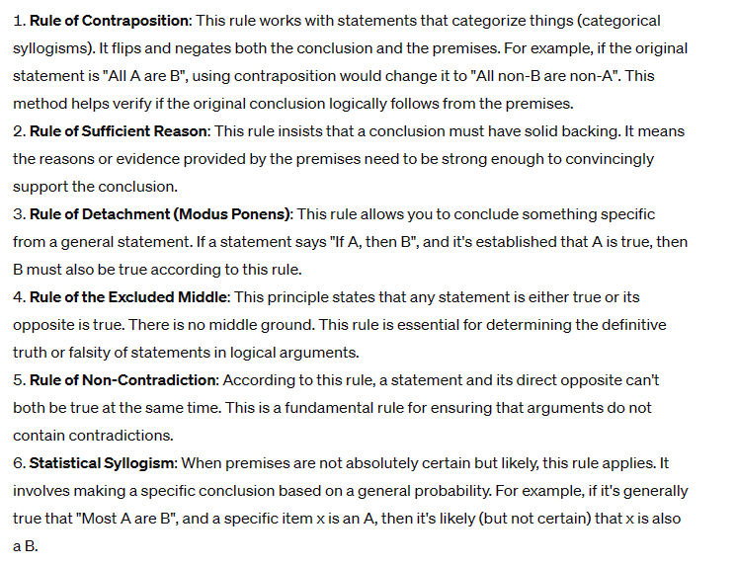

A hypothetical proposition is one that asserts the dependence of one proposition on another. These typically come in two categories:

1. Conditional Statements: These are the "if-then" statements that establish a condition and a consequence. For example, "If it rains, then the ground will be wet." Here, the truth of the ground being wet is contingent upon the occurrence of rain.
2. Biconditional Statements: These statements assert a two-way conditionality, often phrased as "if and only if". For example, "You can borrow the car if and only if you fill up the gas tank." This means that borrowing the car is dependent on filling up the gas tank, and filling up the gas tank means you can borrow the car. Both conditions are strictly linked to each other.

A hypothetical proposition is true when the nexus holds in the real order and false when it does not.

A disjunctive proposition is a statement that gives two or more options, and at least one of the options must be true. It's like saying, "Either this will happen, or that will happen." For example, "Either you'll win or you'll lose."

Imagine you have a choice between two things, and you can only pick one. A disjunctive proposition just presents these two choices. For example, "It's either raining or it's not."

If there are more than two choices in a disjunctive proposition, you can still turn it into a hypothetical statement. However, the outcome in this statement will also involve a choice between options. For example, consider the statement, "If a triangle isn't equilateral, then it must be either isosceles or scalene." This shows that when you rule out one option (equilateral), you still have to choose between the other two (isosceles or scalene).

The strict purpose of the disjunctive proposition of every type is so to limit the choice of alternatives that if one is true, any other must be false.

In everyday conversation, people sometimes use disjunctive propositions (choices between options) in a loose way, not strictly sticking to the format of choosing between clear alternatives. However, even if the strict choice between options isn’t directly mentioned in what they say, it is often implied by the context of the conversation.

A disjunctive proposition is always positive because it presents a set of possibilities, essentially saying that at least one of the given options must be true. When you deny a disjunctive proposition, you aren’t creating a new disjunctive proposition; instead, you're negating the original proposition's assertion that one of the options is true. Although this denial isn't itself disjunctive, it changes the quality of the discussion, which is necessary to oppose and further analyze the original disjunctive proposition.

Even though hypothetical and disjunctive propositions are made up of simpler propositions linked together, they can still be combined with each other. This combination can be just a straightforward joining (bare conjunction) or it can involve more significant logical connections (material conjunction).

In rhetoric, "sine qua non" is a Latin phrase that means "without which not." It refers to something absolutely essential or indispensable. In simpler terms, it's used to describe something that is a must-have or a necessary condition for something else to happen. For example, trust might be the sine qua non for a successful friendship; without trust, the friendship can't exist or succeed.

A strict disjunctive proposition is a choice between clearly defined options that cover all possibilities. For example, saying "The light is either on or off" includes every possible state of the light. When this type of proposition comes from a clear logical division (like dividing all types of light states), it's straightforward and leaves no room for other options. This can be compared to a sine qua non hypothetical proposition (something essential or indispensable) and a definition, which clearly states what something is or isn't. All of these can be straightforwardly flipped around while still making sense. For instance, if you say, "A bachelor is an unmarried man," you can also say, "An unmarried man is a bachelor" without changing the meaning—this is what's meant by being "convertible simply."

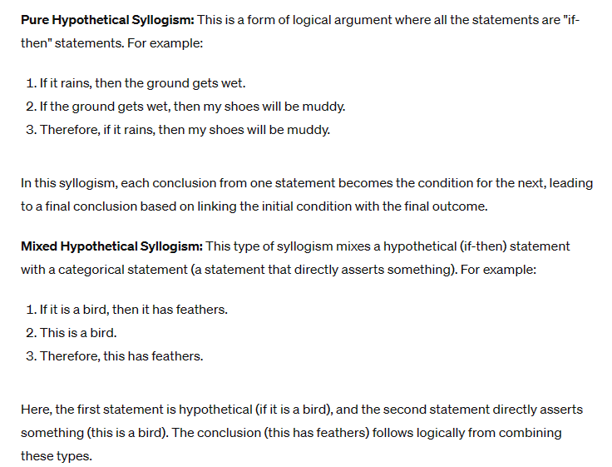

A disjunctive syllogism is a type of logical argument that works with an "either/or" scenario. So, in a disjunctive syllogism, you start with two possibilities, rule out one, and conclude that the other must be the case.

A dilemma is a type of logical argument that starts with a choice between two options (this is the minor premise). It also uses a statement that connects conditions and outcomes (this is the major premise). The conclusion drawn from these premises can either be a straightforward statement or another choice between options. When put together correctly, a dilemma is a valid and effective way to reason things out.

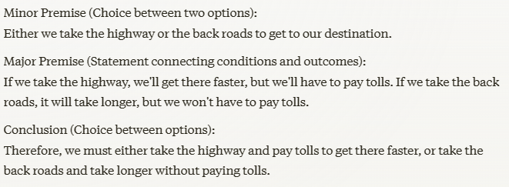

A trilemma is like a dilemma but instead of two options, it involves three. It presents a situation where you are faced with three choices or possibilities, and you need to decide among them. Often, all three options come with their own set of challenges or implications, making the decision complex. This concept is often used to describe a situation where no choice is ideal, and each one involves a compromise or a trade-off.

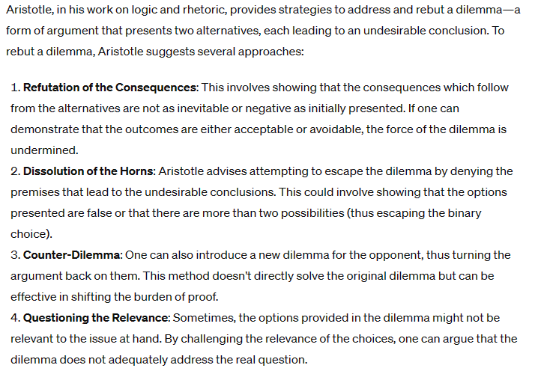

A fallacious argument can be persuasive and appear logical, but it contains a flaw in reasoning that makes it invalid or weak. Aristotle categorized fallacies into two broad types:

1.Material Fallacies: These occur within the content of the argument and are often related to the information being used or the way it's interpreted. These include fallacies like:

* Ad Hominem (Against the Person): Attacking the character of the person making the argument, rather than the argument itself
* Ad Populum (Appeal to Popularity): Arguing something is true because it is widely believed
* Ad Misericordiam (Appeal to Pity): Using pity or emotional appeals rather than logical reasons to persuade

2.Verbal Fallacies: These occur because of the language used in the argument, leading to ambiguity and misunderstanding. Examples include:

* Equivocation: Using a word in different senses in the argument, leading to a confusion
* Amphiboly: Using grammatically ambiguous structures that can lead to misinterpretations

A fallacy is a breach of logical rules that is masked by a semblance of correctness; it represents a flawed reasoning method. In contrast, falsity refers to a mistake in factual accuracy.

Formal fallacies occur due to breaches in the rules that oversee the formal relationships between propositions, and are addressed in discussions of these relationships. Fallacies of opposition, which violate the rules of opposition, include a common error: assuming that if one of two contraries is false, the other must be true, when in fact it should be considered unknown.

Material fallacies originate from the substance of an argument—specifically, the terms, concepts, and symbols used to convey these ideas. They can undermine an argument that may otherwise appear logically valid. Aristotle categorized these fallacies into two groups: six 'fallacies in dictione,' which stem from a concealed assumption that the language does not express, and seven 'fallacies extra dictionem,' marked by a covert, erroneous assumption that the language used does not justify (at bottom).

The Fallacies in Dictione:

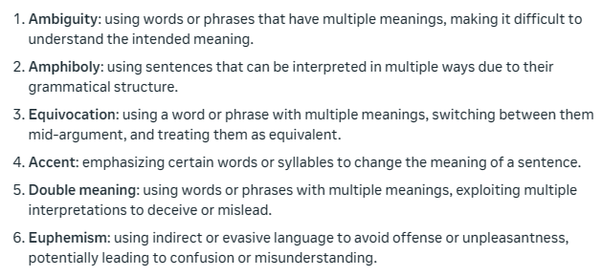

The Fallacies Extra Dictionem:

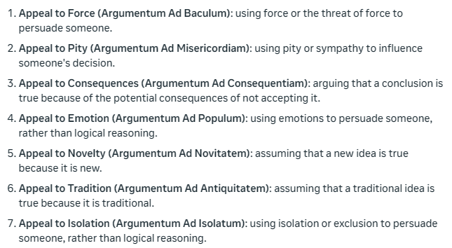

While it is commendable to communicate knowledge understood in its essential, abstract, and general meaning, it is not commendable to communicate trivial or even mischievous information.

Every term can be used in either of the two intentions, and every word can be used in each of the three impositions. The intentions and impositions are reviewed in the box below.

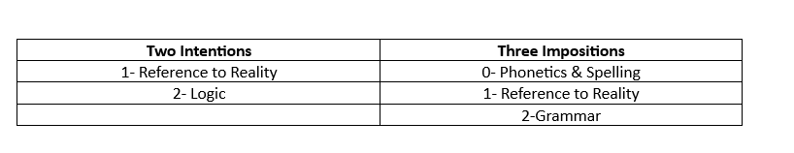

In rhetoric, understanding the two intentions of a term is crucial because it allows you to grasp the complexities of language and communication. The two intentions of a term refer to its:

* Denotation: The literal or dictionary definition of a word, which is its explicit meaning
* Connotation: The emotional, cultural, or associative meaning of a word, which is its implicit meaning

In rhetoric, the three impositions of a word refer to the ways in which language is used to shape meaning and influence others. The three impositions are:

1. Imposition of Extension: This refers to the scope or range of things to which a word or phrase applies. Understanding the extension of a term helps you identify what is included or excluded from a definition or classification.

2. Imposition of Intension: This refers to the qualities or characteristics that define a concept or term. Intension determines the essential attributes or connotations associated with a word or phrase.

3. Imposition of Emotion: This refers to the emotional associations or connotations that words or phrases evoke. Emotions can influence how people respond to language and shape their attitudes and beliefs.

The imposition fallacy happens when we mistakenly assume that a word's meaning in one context applies to all contexts. For example: 'A banana is yellow. Yellow is an adjective. So, banana is an adjective.' This reasoning is flawed because 'yellow' has different meanings in each sentence (first imposition: a color, second imposition: a word type).

When we use terms like 'phonetics' and 'spelling' (or 'orthography') to describe something, we're looking at the most basic level - just the sounds or written symbols themselves, without any added meaning or interpretation. We're essentially stripping away any extra layers of understanding and focusing on the raw sounds or written notation.

Shift of intention" is a mistake where we assume that a term's meaning in one context (first intention) applies to the same term in a different context (second intention), and vice versa. In other words, we wrongly assume that a term's meaning stays the same regardless of the context in which it's used.

This argument is a great example of how things can go wrong: 'Man is rational. Rational is a characteristic. Characteristic is a long word. Long word is a noun. So, man is a noun.' Each statement is true on its own, but the argument is completely flawed because it jumps between different levels of meaning and context. It starts with what 'man' means, then moves to a characteristic of man, then to a type of word, and finally to a type of grammatical term. The conclusion is true, but the reasoning is faulty because it shifts between different planes of discourse.

The term secundum quid means “following this.” In other words, what is true in one case is assumed to be true in another. This fallacy is a sneaky trick used to deceive others or ourselves. It happens when we ignore or downplay small but important details. There are three ways it works:

1. Agreeing to something with conditions, then acting like it's unconditional.
2. Treating an unconditional statement like it has conditions.
3. Swapping one condition for another.

Remember, what's true in one situation or respect may not be true in another. Don't ignore the fine print!

Ignoratio elenchi refers to a mistake in refuting an argument. To truly refute someone, you must prove the opposite of what they said, using the same criteria (subject, predicate, respect, relation, manner, and time). If you prove something else, you're avoiding the main point and arguing irrelevantly.

In short, to refute an argument, you must directly address the original claim, not sidestep it by proving something else.

A good argument addresses the main point directly (this is called "argumentum ad rem"). However, some arguments dodge the issue and focus on irrelevant things instead. These are given special names to highlight their weaknesses and help in identifying when someone is sidestepping a main issue:

* Attacking the person (ad hominem)
* Appealing to popular opinion (ad populum)
* Playing on emotions (ad misericordiam)
* Using force or intimidation (ad baculum)
* Assuming ignorance (ad ignorantiam)
* Appealing to authority or reputation (ad verecundiam)

The argumentum ad hominem fallacy occurs when someone attacks the person making an argument instead of addressing the argument itself. This fallacy confuses the issue with the person involved, and uses personal criticisms or praise as a substitute for logical reasoning.

The argumentum ad populum fallacy happens when someone tries to win an argument by appealing to popular emotions or biases, rather than using logical reasoning. For example, using racist rhetoric to sway public opinion, rather than presenting a sound argument.

The argumentum ad misericordiam fallacy occurs when someone tries to win an argument or get special treatment by appealing to sympathy rather than using logical reasoning. For example, a lawyer might try to get a lighter sentence for their client by emphasizing their personal struggles or hardships, rather than focusing on the facts of the case. Or, someone might try to get out of a parking ticket by claiming they were doing something good, like donating blood, when they were parked illegally.

Argumentum ad baculum is a fallacy that uses threats or intimidation to sway an argument, rather than addressing the issue itself. It's like saying 'agree with me or else...' Instead of using logical reasoning, someone might try to scare you into agreeing with them by threatening consequences, like social exclusion, job loss, or even physical harm.

Four common fallacies - argumentum ad populum, ad misericordiam, ad baculum, and ad ignorantiam - exploit emotions to deceive or manipulate others, rather than building genuine connections. Argumentum ad ignorantiam specifically takes advantage of people's lack of knowledge or understanding, making an argument appear convincing only because others aren't aware of its flaws or counter evidence. These fallacies misuse pathos, a rhetorical technique meant to establish empathy and persuade through emotional connections, instead using emotions to trick or force agreement.

Argumentum ad verecundiam is a fallacy that occurs when someone uses a person's reputation or prestige to support an argument, rather than using logical reasoning. It's like saying 'Expert X believes this, so it must be true!' without considering the actual evidence or reasoning. While it's okay to use expert opinions to support an argument, it's not okay to rely solely on their authority instead of using reason. This fallacy is especially problematic when the person cited isn't an expert in the relevant field, like when a celebrity endorses a product or political cause.

False cause fallacy happens when we mistake a coincidence or unrelated factor for the real reason something is the way it is. Just because two things happen together doesn't mean one causes the other!

Post hoc ergo propter hoc is a mistake where we think something that happens before an event causes the event, just because it happened first. This is different from false cause, which mistakes a reason for a cause. We might see a black cat and then a stock market drop, and think the cat caused the drop. But we're ignoring all the times the cat crossed our path without anything bad happening. Even if the cat always preceded bad luck, it wouldn't mean the cat caused it - correlation doesn't equal causation!

"Begging the question" is a mistake where you use a conclusion as a reason to support itself. It's like saying "Something is true because it's true", which isn't a real argument. You're just repeating yourself instead of giving a genuine reason or evidence.

A "shuttle argument" is a way of arguing that switches between different ideas or perspectives to support a main point. It's like presenting different sides of an issue to appeal to different people and address potential counterarguments.

“Arguing in a circle" is a logical mistake where someone uses a conclusion as part of their argument to prove that same conclusion. It's like saying "X is true because X is true", which doesn't actually prove anything!

A question-begging epithet is using a loaded label or phrase that already assumes what you are trying to prove as true. It's a form of circular reasoning, where the conclusion is built into the premise itself.

The complex question fallacy is like begging the question. It's when a question assumes part of the answer and demands a simple "yes" or "no" response, when the correct answer needs to be more detailed and nuanced. This fallacy is often used in cross-examination to trick witnesses into contradicting themselves and weakening their testimony.

Logic is the study of how to think correctly and arrive at truth. Just as metaphysics looks at everything in general, logic looks at all thoughts and ideas in general, focusing on what makes them true or false.

Truth is:

1. What is thought must represent what is.
2. Thoughts must be consistent among themselves.

Thinking and reasoning have two crucial aspects. First, we need the material to reason with, which includes ideas, facts, and information. This material comes from our experiences and observations, which we process through conception and induction. Second, we need the process of reasoning itself, which involves connecting and drawing conclusions from the material. Formal logic provides the rules for correct reasoning, but it relies on the material we've gathered from our experiences. In other words, we need to observe, understand, and form ideas before we can reason with them effectively.

The human senses can help a being to develop knowledge. These are sometimes referred to as “sense powers” and are things like:

* Sight
* Hearing
* Touch
* Taste
* Smell
* “Internal Senses”: things memory and imagination

Intellectual powers are sometimes talked about in rhetoric and this means things like:

* Intellect- that seeks truth
* Rational memory
* The will- that seeks “good”

It is believed that the intellect can function intuitive in rhetoric using:

* Abstraction: the ability to simplify complex ideas, see connections, and focus on the essential concepts, often through mental shortcuts and implicit understanding
* Conception: the ability to form a mental grasp or understanding of an idea, concept, or situation, often through a sudden insight or a vague but compelling sense of meaning
* Induction: the ability to generalize or draw broad conclusions from specific experiences, observations, or instances, often through an instinctive or unconscious process

According to Aristotle, intuition plays a crucial role in rhetoric as it enables speakers to appeal to commonly held beliefs, establish credibility through their character, and understand the emotional state of their audience. Intuition also helps speakers craft persuasive arguments that are grounded in logical reasoning and evidence, and allows them to connect with their audience on an emotional level. By leveraging intuition, speakers can create more effective and persuasive arguments that resonate with their audience. Three kinds of intuitiveness are:

1. Enumerative induction: a form of reasoning that involves making generalizations based on specific observations. It works by observing a number of individual instances, noticing a pattern or regularity among them, and then generalizing that pattern to all instances, including those that have not been observed.
2. Intuitive induction: the power of obtaining knowledge that cannot be acquired through inference or observation, by reason or experience. It is a method of reasoning involving an element of probability and forming a conclusion based on what is known or observed.
3. Dialectic or problematic induction: a form of inductive reasoning that seeks to resolve contradictions and overcome limitations of enumerative induction. It involves identifying a problem or contradiction, analyzing opposing views, and synthesizing a new understanding that reconciles the contradictions. This iterative process aims to arrive at a more comprehensive and nuanced conclusion, recognizing that opposing views may have some truth. By reconciling contradictions, dialectical induction reaches a deeper understanding of the issue, offering a more holistic perspective.

Induction is a way to derive general truths from specific examples. What is always observed in these examples is likely a fundamental part of their nature. Induction helps us discover truth, but it's not a way to prove or reason about truth. Since the natural world is complex, we need a systematic approach to prepare for induction. Scientific methods help us investigate natural phenomena, identify what's essential and typical, and present clear data to our minds. Then, our minds can make an intuitive leap to understand the general truth. Scientific methods ensure precision in our investigation, and induction and deduction work together to help us understand the world. Each science focuses on a specific aspect of nature, like mathematics on quantity or physics on motion, to discover its underlying laws.

In rhetoric a cause is something that has a positive influence in helping a thing become what it is.

In rhetoric a condition is that which in any way enables a cause to act in producing the effect, but to which the effect owes none of its characteristics.

In rhetoric a determining agent is a condition which sets in motion causative factors.

Aristotle’s four metaphysical causes are:

* Material Cause: What something is made of
* Formal Cause: The shape or form it takes
* Efficient Cause: How it was made or came to be
* Final Cause: Its purpose or reason for existing

Uniformity of causation is a basic assumption in natural sciences. It generally means:

"Same cause, same conditions, same effect."

Scientific induction in rhetoric is a method of reasoning that moves from specific instances to a general conclusion. It involves collecting instances and forming a generalization that applies to all instances. Induction argues from the probability that known instances are parallel to and illuminating of those less well known. It follows a trail of clues, learning from experience, and observing patterns and regularities to form a conclusion that goes beyond what's contained in the premises.

The five steps of the scientific method are:

* Question: Ask a question about what you observed
* Guess: Make an educated guess (hypothesis) to explain what you saw
* Test: Design an experiment to test your guess
* Refine: Use the results to refine your guess or come up with a new one

The method of agreement is a way to figure out the cause of something by finding the one thing that is always present when it happens.

The method of difference is a way to figure out the cause of something by finding the one thing that is present when it happens, but absent when it doesn't.

The Joint Method of Agreement and Difference is a way to figure out the cause of something by combining two approaches: finding what's always present when it happens, and finding what's present only when it happens. This method uses both the Method of Agreement (finding the common factor among all instances) and the Method of Difference (comparing instances where the effect occurs with instances where it doesn't) to identify the cause.

The Method of Residues is a way to figure out the cause of something by subtracting out known causes and seeing what's left over.

The Method of Concomitant Variations is a way to figure out the cause of something by looking for factors that change together with the effect. This method involves identifying changes in the effect and looking for corresponding changes in possible causes, to determine if there is a relationship between them.

Verification of a hypothesis is the process of testing and confirming that a hypothesis is true or accurate. It involves:

* Testing the hypothesis through experimentation or observation
* Analyzing the data collected to see if it supports the hypothesis
* Drawing conclusions based on the results
* Confirming that the hypothesis is consistent with the data and observations

In other words, verification is the process of proving or confirming that a hypothesis is correct, and it's an essential step in the scientific method.

To be sure a general law is true, you need to use logic to prove it. This helps confirm that the law is correct and explains how things are related.

A demonstrative syllogism is a type of logical argument that uses two true statements to arrive at a conclusion that is definitely true.

Philosophy represents the greatest unity and simplicity to which unaided human reason can attain.

In rhetoric, the four things that contribute to progress toward unity are:

* Clarity (perspicuitas): Using clear and concise language to convey your message
* Brevity (brevitas): Keeping your message brief and to the point
* Order (ordo): Organizing your thoughts and ideas in a logical and coherent way
* Connection (coniunctio): Using transitions and connections to link your ideas together smoothly

There are four steps in the synthesis of knowledge:

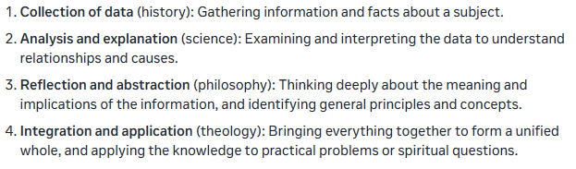

Speculative philosophy is a way of thinking about the big picture of life, the universe, and everything. It's a type of philosophy that:

* Tries to understand the nature of reality and the universe as a whole
* Goes beyond what we can observe and measure
* Uses intuition and reasoning to build a comprehensive worldview
* Seeks to understand the deeper meaning and connections between things

Practical philosophy is focused on solving real-world problems. This branch of philosophy deals with ethics and how to apply ethics to everyday life.

Normative ethics is a branch of moral philosophy that deals with what is right and wrong. This branch of philosophy deals with moral rules and how they apply to human actions and society.

Abstraction is a crucial process in both science and philosophy, involving the identification of essential features and ignoring non-essential details. By abstracting away from specific details, scientists and philosophers can gain a deeper understanding of the world and develop new ideas and theories.

Philosophy integrates the knowledge gained from various scientific disciplines, providing a comprehensive understanding of the world and reality. It seeks to synthesize the findings of different sciences, identify common principles and patterns, and offer a rational and coherent framework for understanding. By doing so, philosophy comes closest to revealing the whole truth, providing a complete and integrated picture of knowledge, to the extent that it can be known through reason and human inquiry.

Theology's primary function is to complement human knowledge by providing insights and understanding that exceed what human reason alone can discover. It offers a deeper and more profound understanding of the world and reality, accessing knowledge that is not accessible through human intellect alone, such as revelation, divine wisdom, and spiritual truths. Theology supplements and enriches human knowledge, providing a more complete and comprehensive understanding of the world and our place in it.

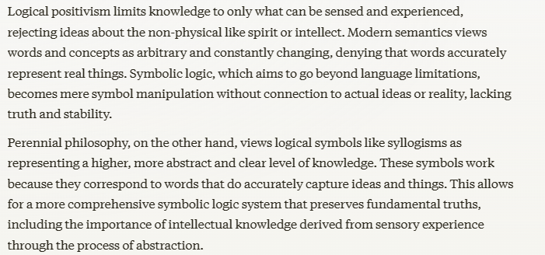

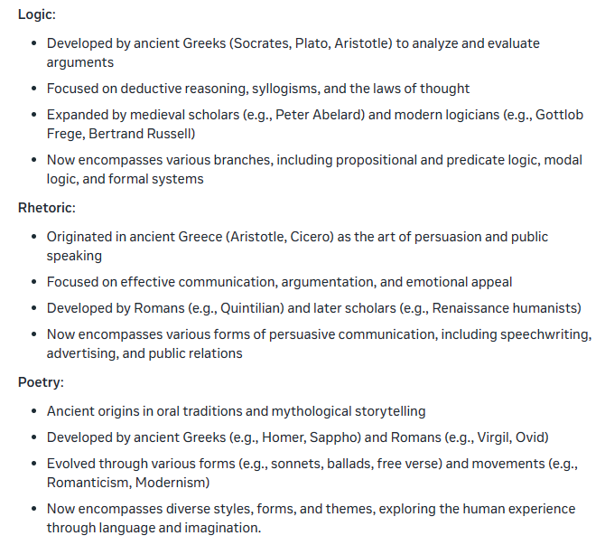

Aristotle divided logic into three main forms:

1. Scientific Demonstration: Also known as apodeictical argumentation, this form of argumentation aims to prove a conclusion with absolute certainty, using scientific principles and empirical evidence. This type of argumentation is concerned with establishing universal and necessary truths.
2. Dialectic: This form of argumentation involves reasoning and argumentation based on opinions and probabilities. Dialectic is concerned with exploring different perspectives and testing hypotheses, with the goal of arriving at a deeper understanding of the subject matter.
3. Sophistic: Also known as eristic argumentation, this form of argumentation is concerned with winning an argument or persuading an audience, often using rhetorical devices and emotional appeals. Sophistic argumentation is focused on the art of persuasion, rather than the pursuit of truth or understanding.

Aristotle saw rhetoric and dialectic as two closely related fields that deal with opinions and probabilities, rather than absolute certainties. They are unique in their ability to present arguments for multiple sides of an issue. While dialectic focuses on big philosophical questions, using a question-and-answer format and targeting experts, rhetoric focuses on specific, practical issues like politics, using continuous speech and aimed at a general audience. In essence, dialectic explores ideas with experts, while rhetoric persuades a wider audience on specific issues.

Persuasion is achieved by means of logos, pathos, and ethos.

Style is characterized by good phrasing, good grammatical structure, pleasing rhythm, clear and appropriate language, effective metaphor, etc.

Arrangement is the order of parts: introduction, statement and proof, conclusion.

According to Aristotle, poetry is a form of imitation that recreates life experiences through storytelling. Instead of addressing the reader directly, the author creates characters that speak and act, allowing readers to connect with them through their imagination. This immersive experience is the essence of poetry, and it doesn't necessarily require the use of verse or rhyming language.

Poetic is the imitation of an action by which agents to whom we ascribe moral qualities achieve happiness or misery. Their thought and character are shown as causes of their actions which result in success or in failure.

The three major forms- according to Aristotle- are:

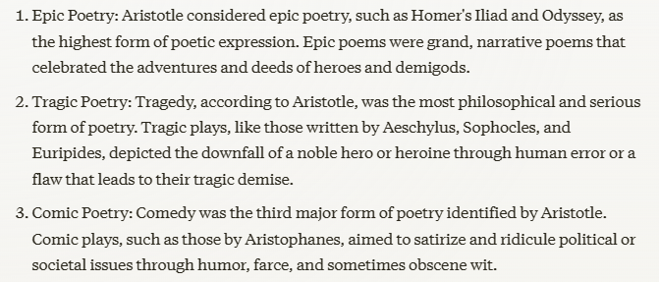

The minor forms are:

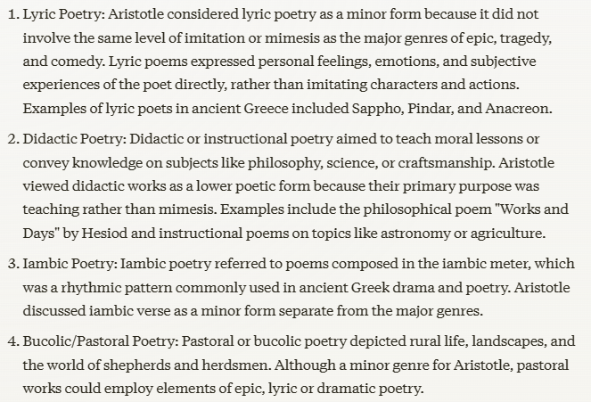

A plot is a combination of incidents so closely connected by cause and effect that not one of them may be transposed or withdrawn without disjoining and dislocating the whole. This causal connection constitutes unity of action, the one unity essential to every poetic work. Plots must have a beginning, middle, and end.

The parts of the action are (1) the situation or exposition; (2) the complication or rising action; (3) the resolution or falling action. The basic analysis of plotted narrative discovers the beginning of the action, the turning point (the logical climax), and the denouement or final outcome (the emotional climax).

Plausibility is absolutely essential to a story. It is the achievement of illusion and inward consistency. No matter how imaginative or even fantastic a story may be, it must create illusion; it must seem real. A writer may secure plausibility by the following means.

* Motivation
* Forecast
* Detail
* Setting
* Tone

Angle of narration includes point of view, focus, the use of frames, and the degree of dramatization.

Dramatic scenes create an experience for the reader to share imaginatively, through dialogue, reverie, detail of action, and vivid picturing details. Nondramatic narration merely gives the reader information through the author’s explanation and summary of events.

A story is usually told in third- or first-person point of view. In first-person point of view, the narrator may be the main character or a less important character. In third-person point of view, the story may use well-informed narration and present the thoughts of many or all of the characters, or it may use limited well-informed narration and only present the thoughts of one character. Second-person point of view uses a narrator who speaks directly to the reader.

Motivation of characters and action, forecast, and the structure of the story add to suspense.

A character is an imagined figure who takes a role in a story. Characters can be round, which means they are multidimensional, or flat, which means they can be distinguished by one outstanding trait.

Theme is the underlying thought of the whole story and can be stated in one sentence. It is usually a conviction about life, which might have been the subject of an essay or a sermon but which has been expressed instead in a poetic communication: a story, drama, or novel.

Modern literary criticism uses the term diction in a narrower sense to mean the words which the author uses and considers diction one element of style. Style refers to how the writer manages the elements of the story. In a broad sense, it includes every choice the writer makes, but since most of those choices are discussed under other headings, usually the focus is on the following elements of style: tone, diction, and syntax.

Syntax is sentence structure. Both the length and construction of sentences are components of syntax. Grammatically, sentences can be simple, compound, complex, or compound-complex. Sentence fragments, elements punctuated as sentences that are not grammatically sentences, can also be found in stories. Rhetorical elements of sentence structure, such as the use of parallel structure or periodic sentences, are part of syntax.

Figurative language includes any deviation, either in thought or expression, from the ordinary and simple modes of speaking. This would include the language of ordinary people moved by excitement to adopt short cuts and turns of expression which give their speech liveliness and vividness not ordinarily found in it.

Tropes are devices that involve a deviation from the literal or conventional meaning of words, phrases, or expressions.

Some common tropes in stories and literature include:

* Metaphor: A direct comparison between two seemingly unrelated things without using "like" or "as." For example, "All the world's a stage."
* Simile: A comparison between two things using the words "like" or "as." For example, "She's as brave as a lion."
* Personification: Attributing human qualities or abilities to non-human things or abstract concepts. For example, "The wind howled through the trees."
* Hyperbole: Exaggerated statements or claims not meant to be taken literally. For example, "I've told you a million times."
* Irony: A contrast between what is stated and what is meant or expected. For example, describing a dangerous situation as "a walk in the park."
* Symbolism: Using objects, characters, or situations to represent ideas or concepts beyond their literal meaning. For example, a dove representing peace.
* Allusion: An indirect reference to another work of literature, historical event, or cultural phenomenon. For example, referring to someone as "a modern-day Hercules."

A simile expresses through the words, “like” & “as”, or resembles an imaginative comparison between objects of different classes.

Onomatopoeia is the use of words or rhythms whose sound imitates the sense.

Personification is the attribution of life, sensation, and human qualities to objects of a lower order or to abstract ideas. Personification is based on the relation of subject and adjuncts. An adjunct is an accident or a quality that inheres in a subject.

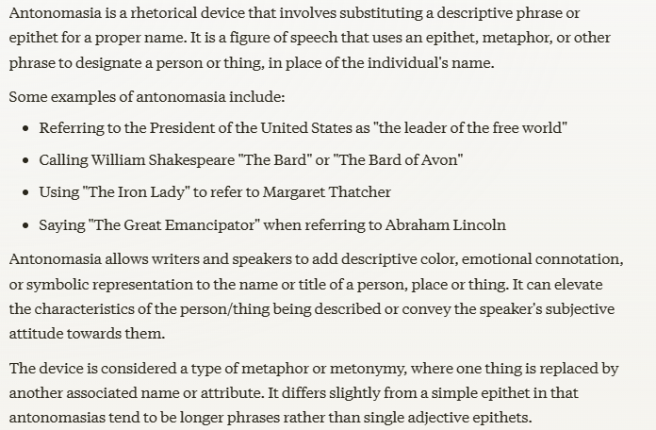

Metonymy is a literary device that involves replacing a word or phrase with a closely related one. It can involve swapping a main idea for a supporting detail, or an effect for its cause, and vice versa. This includes switching between different types of relationships, such as the agent, purpose, material, or underlying structure. If an effect is signified by a remote cause, the figure is called metalepsis, a kind of metonymy.

Synecdoche is a figure of speech that uses a part to represent the whole, or vice versa. It's a shortcut to describe something, like saying "wheels" for "car" or "White House" for "government". It adds flavor and depth to language, and helps us paint a picture with words.

Irony is a figure of speech that uses opposites to convey meaning. When we use irony, we say one thing but mean the opposite. It's a way of expressing an idea or feeling by saying something that is actually the opposite of what we intend.

Ineffective figures of speech in rhetoric are techniques that may have been overused, misused, or poorly executed, which can undermine the speaker's or writer's intended message or persuasive power. Some examples include:

* Clichés: Overused and predictable metaphors or phrases that lose their impact.
* Mixed metaphors: Combining two or more incompatible metaphors, causing confusion.
* Overused allusions: References to familiar people, places, or events that become trite and lose their significance.
* Forced or contrived figures of speech: Using techniques like metaphor, simile, or personification in a way that feels unnatural or artificial.
* Inconsistent tone: Using figures of speech that clash with the intended tone or audience.
* Overreliance on figures of speech: Relying too heavily on rhetorical devices, making the language seem overly elaborate or insincere.
* Inappropriate use of irony, sarcasm, or hyperbole: Using these techniques in a way that comes across as insensitive, mocking, or misleading.
* Ambiguous or confusing figures of speech: Using language that is unclear or open to multiple interpretations, leading to confusion or misinterpretation.

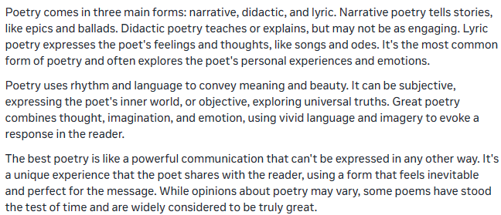

Parallelism in rhetoric is a literary device that involves the repetition of similar grammatical structures or elements, such as words, phrases, or clauses, to create a harmonious flow and rhythm in writing or speech. There are several types of parallelism, including:

1. Synonymous parallelism: This type of parallelism involves the use of similar words or phrases to express the same idea.
2. Antithetical parallelism: This type of parallelism involves the use of contrasting words or phrases to highlight their differences.
3. Synthetic parallelism: This type of parallelism involves the expansion of ideas to create a parallel structure, often using synonymous or antithetical parallelism.

A caesura is a break or pause within a line of verse. The caesura is a rhetorical device that can be used to emphasize certain words or phrases, create a dramatic effect, or separate ideas within a sentence. There are three types of caesura:

1. Initial caesura: occurs at the beginning of a line
2. Medial caesura: occurs in the middle of a line
3. Terminal caesura: occurs at the end of a line

Caesura can also be classified into two other categories based on the syllable that precedes it:

1. Feminine caesura: occurs after an unstressed syllable
2. Masculine caesura: occurs after a stressed syllable

Cadence is the natural rhythm of speech, created by the ups and downs of the speaking voice. Free verse poetry, also known as vers libre, harnesses this natural cadence instead of following a strict meter or rhyme scheme. This style was popularized by French symbolist poets in the late 19th century and is now widely used in modern poetry. Interestingly, free verse can also be found in ancient texts like the Bible, particularly in the Psalms and the Song of Solomon, which showcase a natural, rhythmic flow.

Meter is a rhythmic pattern in poetry, created by a consistent arrangement of stressed and unstressed syllables. It follows a specific and repeating structure, which gives poetry a musical quality. Meter is a fundamental element of traditional English poetry, and has been used by many famous poets to create a sense of rhythm and musicality in their work.

Rhythm and meter are related but distinct. Meter is a consistent pattern of stressed and unstressed syllables, while rhythm is the natural flow and cadence of language. Two poems can share the same meter, but their rhythms can be quite different, depending on the way the words and ideas are arranged.

Rhyme is identity of sounds at the end of two or more words, with a difference at the beginning. The rhyming must begin on stressed syllables.

* Masculine Rhyme: occurs when a single syllable at the end of the word, which is stressed, rhymes. Examples include lean and green, reuse and abuse, produce and reduce, betray and portray, and persist and resist.
* Feminine Rhyme: matches two or more syllables, with the last syllable being unstressed. Examples include measure and leisure, power and hour, rumor and humor, duty and beauty, and incarnation and reinstation.

Imperfect rhyme or slant rhyme refers to words that are not identical in rhyming sounds.

End rhyme is the rhyming of a word at the end of one line with a word at the end of another line. This is the most usual form.

Internal rhyme is the rhyming of a word in the middle of a line with another in the same line, usually at the end of it.

Alliteration is identity of sound at the beginning of two or more words in the same line.

* "She sells seashells by the seashore." (repetition of the "s" sound)
* "Peter Piper picked a peck of pickled peppers." (repetition of the "p" sound)
* "Fuzzy felines frolic fearlessly." (repetition of the "f" sound)

A stanza is a group of lines in a poem, usually four or more lines, that form a unit or a section of the poem. Stanza is an Italian word that means "room", and stanzas are often thought of as the rooms within a poem, each one with its own distinct character and theme.

In poetry, a verse is a single line that can stand alone or be part of a larger poem. Verses can vary in length and structure, and are often arranged in stanzas to create a poem. They're used to express thoughts, ideas, and emotions, and can have a specific rhythm, meter, or syllable count.

An essay can be broadly defined as a short prose work on a single topic.

The familiar essay aims to please rather than to inform the reader. It stands between story and exposition, and, like the lyric, it is a subjective communication of thought and feeling colored by the personality and mood of the author.

The style of the formal essay varies depending on the theme, purpose, and audience. It would include philosophical, scientific, religious, and historical writing.

Before you begin to write, carefully think through your purpose and the means to gain and hold the interest of the particular readers you address. Find a common ground with them. Begin perhaps with a question or an unexpected statement. Do not write what is obvious, trite, or insipid to them—what anyone can see on the run. Some other tips are:

* Learn as much about a subject as possible
* Look at contrasts
* Look at definitions
* Look at similarities
* Use outlining to coordinate topics
* Keep sentences short
* Use verbs to express action
* Make sentences clear

Students who have learned to think rhetorically about writing can tackle new tasks without extensive scaffolding. They have their own strategies and processes for responding to unfamiliar literacy demands. They can change how they write in response to diverse audiences, purposes, and occasions.

Writing rhetorically means paying attention to the needs of the author and the needs of the reader rather than the needs of the teacher— or the rules in the textbook.

Formulas replicate the surface features of academic writing but don’t allow writers to engage in real composing. A rhetorical mindset helps students see themselves as independent writers who are capable of figuring out how to write well in new situations.

The goal of a rhetorical approach is transfer of learning. Transfer of learning is the use of past learning in new situations. Because situations vary widely, making appropriate use of prior knowledge and skills often calls for significant adjustments. Teaching writing for transfer thus helps students think differentially about literacy tasks and contexts. That is, students have to assume that reading and writing in one setting could be different from reading and writing in another setting.

Transfer happens as a result of deep, internalized, principled learning. It’s driven as much by learners’ beliefs and attitudes as their knowledge and skills.

When students are given the responsibility of making rhetorical decisions in their writing, they develop a deeper understanding of the writing process, often referred to as 'writer's brain.' This means they learn to constantly consider and evaluate various options, much like a writer does when composing, which helps them become more effective and independent writers.

The National Council of Teachers of English identifies essential ideas for teaching writing effectively. These ideas include understanding why people write, the different types of writing, and how to write for various audiences and purposes. Teachers should also know how to incorporate digital tools, teach writing for different subjects, and design courses that allow students to write for different reasons and audiences.

When we teach writing rhetorically, we support students in becoming independent problem solvers who are well prepared to take rhetorical action: to discover their own questions, design their own inquiry process, develop their own positions and purposes, and contribute to conversations that matter to them.

The way scientists communicate with each other in their own discourse communities does not necessarily match the conventions of academic writing being taught in many high schools. This is important because the traditional ways of scientific writing are evolving to move beyond old restrictions.

Beginning with considerations of audience, context, purpose, and genre is a key part of writing rhetorically.

Rhetoric’s fundamental concern is how to communicate effectively in diverse contexts.

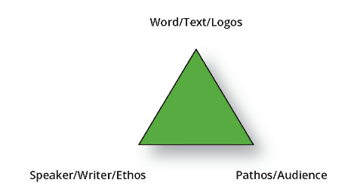

The different purposes and genres of writing both grow out of and create varied relationships between the writers and the readers, and existing relationships are reflected in degrees of formality in language, as well as assumptions about what knowledge and experience are already shared, and what needs to be explained.

The Common Core State Standards also calls for adaptability and responsiveness in students’ communication practices, recommending that students write “for a range of tasks, purposes, and audiences” while focusing on “what is most significant for a specific purpose and audience”.

But the problem with standardizing literacy practices across diverse rhetorical contexts is that this method doesn’t prepare students to change how they read and write when the situation demands. What’s more, training students to expect writing to follow the same standards regardless of context can result in serious misreading of texts. A student might think a writer is doing something “wrong” if they don’t follow the rules the student has been taught.

A problem occurs when students turn feedback into rigid writing rules. This happens when feedback is presented as universal guidelines or when formulas are given in advance to avoid grading issues. As a result, students may adopt an inflexible approach to writing, limiting their ability to adapt to different contexts and purposes.

Argumentative writing involves a flexible approach to developing ideas. Depending on the issue and the writer's context, it may incorporate various compositional patterns to arrive at a conclusion. This means that writers may use a range of strategies to build their argument, rather than relying on a single approach.

Separated from the act of thinking and creating, writing becomes merely a skill that can be learned through grammar drills and through the production of pointless essays that students do not want to write and that teachers do not want to read.

Teaching writing through strict rules can have a negative impact on students' attitudes. High-achieving students may become disillusioned with academic writing conventions when they see success as simply pleasing their teachers' arbitrary preferences, rather than genuinely communicating ideas. Other students who earnestly complied with the conventions prescribed by their teachers are deeply dismayed when they discover those rules don’t apply in new situations

Educating students for adaptability presumes a future world that doesn’t just maintain the status quo.

There are two student responses to unfamiliar tasks or content that are especially concerning. Both responses limit students’ ability to adapt to new situations: the first, by attributing the unfamiliarity to a deficiency in the students’ preparation, so that they feel they just aren’t ready (and perhaps don’t belong); and the second, by resisting any changes to the “rules” or methods the students previously mastered in their education.

(1) “I don’t know why I never learned this.”

(2) “That’s not how I learned this.”

Reading or reviewing opposing texts on the same topic, but meant for different audiences, can help the students to see how they can adapt their writing. If your students are new to rhetorical analysis, you’ll probably need to offer extra support for reading and annotating these kinds of passages. Students may need more help understanding the concepts of audience, purpose, context, and genre, too.

To successfully apply knowledge learned from one subject to another, a student must be able to:

* Compare and contrast contexts (including the people and places involved)
* Adjust their problem-solving skills and communication strategies as needed and appropriate

Repeatedly using the same skill is different from transforming that skill for new purposes.

Transfer involves not only recognizing similarities between situations, but also the ability to adapt and apply knowledge in a new context. This requires transforming and expanding existing knowledge to make it relevant and effective in a different situation.

Teaching transfer involves developing students' comprehensive knowledge and skills, including procedural, conceptual, and conditional knowledge. This "expansive framing" approach helps students connect new learning to prior experiences, recognize patterns, and adapt their knowledge to tackle complex problems and novel situations, preparing them to apply their learning in a variety of contexts.

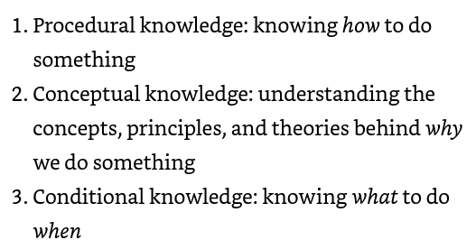

Some of our writing scaffolds—especially overly prescriptive templates and formulas—have interfered with the development of students’ procedural knowledge. The process that many students use is simply to wait for the teacher to tell them what to do.

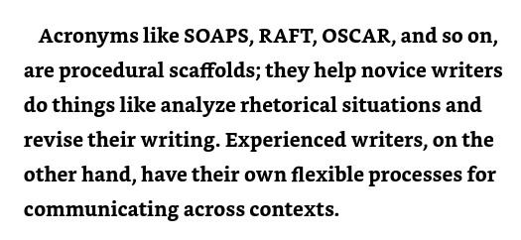

Having students read articles and condense the main idea into a brief summary helps them develop metacognitive skills. By reflecting on their thought process, they articulate how they pinpointed the key concept and what strategies they employed to distill it into a concise summary, making their thinking visible and tangible. The following prompts help them to deepen their learning by helping them look at how they handled any roadblocks along the way.

* What language choices did you make?
* What organizational choices did you make?
* Why did you write it that way?
* How did you make those choices?
* What were your other options?
* What worked?
* What didn’t?
* What might you do differently next time?
* What did you learn about your writing process?

Deep conceptual knowledge is needed to appropriately apply learning in new contexts. Experts possess a deep understanding of conceptual knowledge, which enables them to approach new information with a unique perspective. Their mastery of concepts allows them to recognize patterns, connections, and inconsistencies that may not be apparent to those with less expertise, and to integrate new information into their existing knowledge framework.

Threshold concepts are transformative ideas that revolutionize a writer's perspective, thinking, and communication. Once grasped, they unlock new angles, deeper understanding, and improved organization, enabling writers to tackle complex topics with clarity and coherence. By mastering threshold concepts, writers develop enhanced analytical skills, identifying patterns and nuances, and gain the confidence to effectively communicate their ideas, ultimately elevating their writing to new heights. Here are some ways to help students practice mastery of threshold concepts:

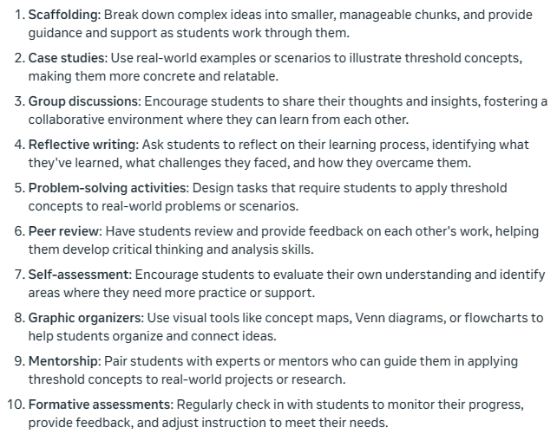

Understanding rhetorical concepts like genre, audience, and purpose helps students adapt their writing skills to different contexts, recognizing when and how to apply them effectively. This enables flexible and effective writing, tailored to engage specific audiences and achieve specific purposes. Some exercise that can be used to sharpen or develop conditional knowledge skills include:

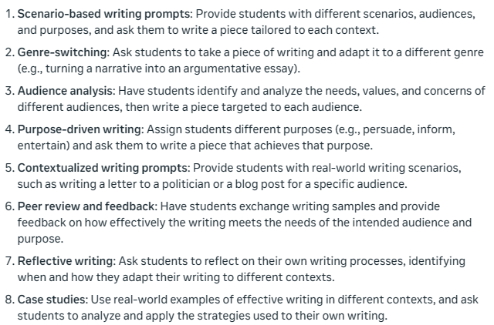

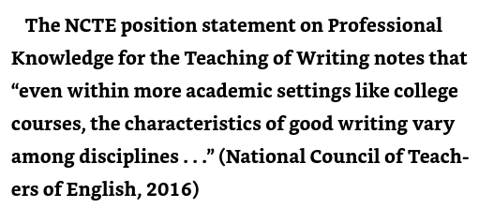

We empower students when we help them understand the rationale for written language conventions—for instance, how capitalization draws attention to the status of a word or how using lowercase letters when capitalization is expected can cause readers to reexamine their assumptions and priorities.

How we frame instruction significantly affects our students’ perception of the value of what they’re learning and of their roles as learners. As teachers, we’re providing instructional framing anytime we introduce a lesson, establish a learning goal, or assign a task. We can frame an activity as something students just have to do to earn points or as an aspect of lifelong intellectual and professional growth.

Few of us make it in life without faking it first. What we don’t want is for students to confuse faking it with making it. Too often, learning stalls out at the mimicry stage. Even worse, we sometimes teach toward mimicry instead of mastery by giving students reductive formulas to follow instead of authentic rhetorical problems to solve.

Some of our scaffolds help students see beyond the task or lesson to the larger value of the skills, knowledge, and dispositions they’re developing. But other scaffolds significantly narrow students’ views of learning. This is especially true in cases in which the scaffold does the work for students.

If the essay organizers and sentence starters are used primarily with the goal of helping students complete a task they seemingly can’t complete on their own, chances are the learning students carry away with them is that writing is a matter of waiting for someone else to tell you what to do.

Over-scaffolding is a cheat that doesn’t help students win the game. It might accelerate the mimicry stage—for instance, by enabling students to more quickly imitate the conventions of academic discourse—but it doesn’t help students develop the principles and processes that produce academic texts in authentic disciplinary contexts.

“Sentence Unpacking” is an exercise that can help students to analyze how different syntactic structures create meaning. It involves paraphrasing and discussing meaning with other students.

Collaborative Text Reconstruction is an additional strategy for helping developing writers learn how language works. The goal of this activity is to elicit a paragraph of student writing based on a mentor text. Using these paragraphs, teachers can informally diagnose students’ strengths and weaknesses in the area of sentence construction. At the end of the activity, students will edit their paragraphs, applying what they have learned about grammar, usage, and mechanics. They will then compare their paragraphs with the original, paying particular attention to verbs, subjects, and sentence structure.

If students perceive that their prior learning and experiences—including, perhaps, their home language and culture—are not valued and relevant in higher education and, indeed, that they must erase what they already know in order to achieve more sophisticated understandings, they may revert to waiting for an instructor to tell them the new rules of the game instead of looking for opportunities to make their own intellectual connections.

Inclusive teaching and transfer of learning both involve viewing all prior knowledge, skills, and dispositions as assets with the potential to be meaningfully redeployed in new situations. This means that even knowledge of how to write a formulaic five-paragraph essay can be a helpful starting place if it gets changed up for a new purpose.

Our culture's adversarial approach to argumentation, rooted in centuries-old Western tradition, often prioritizes defeating opponents over collaborative problem-solving. This historical perspective has reinforced social hierarchies and male dominance by valorizing aggression. Research indicates that this legacy continues, with male and socioeconomically privileged students disproportionately dominating classroom discussions, perpetuating a culture of competition over collaboration.

While logical thinking skills are essential, we must avoid exaggerating their problem-solving potential. Without a genuine willingness to engage with diverse perspectives and listen openly, advanced argumentation and reasoning abilities may actually create more issues than they resolve.

Mapping is a good strategy for moving students beyond a surface understanding of a concept. In this activity, students work collaboratively to identify the essential characteristics of inquiry and to generate short lists of examples.

If we know why the people we are trying to persuade are angry, we may become more sympathetic and may see our own position in a different way and make different arguments. As we become more open to the arguments the other makes, dialogue becomes more possible and we may become more persuasive because of it.

One exercise to help student determine what a rhetorical situation is (a situation that can be changed by effective communication) is to work through the questions below and discuss to what extend a rhetorical action is needed.

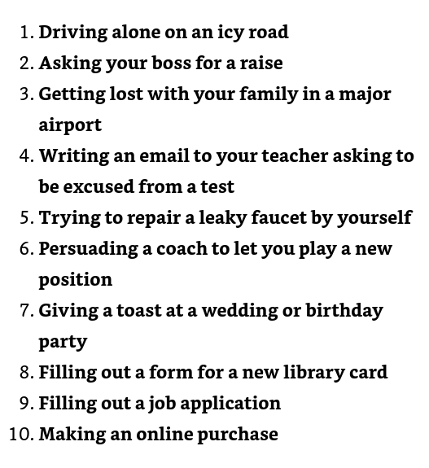

Dialogue is a form of inquiry; it’s a way of learning more about ourselves and our world. There are three distinctive features of dialog:

1. Equality and the absence of coercive influences
2. Listening with empathy
3. Bringing assumptions into the open

People typically have two reasons to engage in dialogue: to strengthen social relationships and to solve problems.

Several behaviors that are not characteristic of effective dialogue include:

* Tuning out views we disagree with
* Preparing a rebuttal instead of listening to what someone is saying
* Seeking only to reinforce our own prejudices

Academic argument implies a reasoned approach to issues. In an academic community, people also hold opposing viewpoints, but they debate in order to modify and strengthen their positions. Through the deliberative and respectful exchange of viewpoints, each side “wins” by attaining a deeper understanding of the issue.

One method of encouraging students to engage in a healthy debate is to have a “Socratic Seminar” where an issue can be discussed in a way that models exploring issues positively. The table below shows some differences between having a debate versus a discussion.

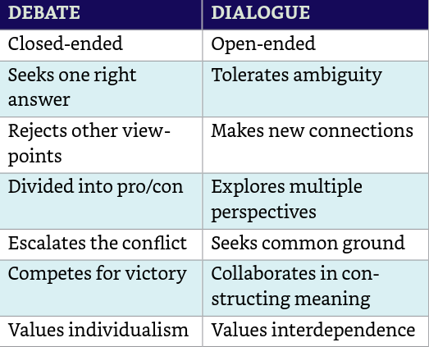

How we teach students to engage the views of others in face-to-face conversations has important implications for how they learn to engage the views of others in written conversations.

Exigence is the word contemporary rhetoricians use to describe the need or problem that motivates us to write. A rhetorical exigence is a “defect” or “obstacle” that can be changed by rhetorical action.

Writers must carefully listen to a conversation to determine what others are saying and how those viewpoints are related. A question is at issue when it is the shared concern of a group.

Kairos can be defined as knowledge of “what to say when” or “the right words at the right time.” Kairos also involves understanding what is fitting and proper for a particular occasion. Many scholars see this kind of conditional knowledge as essential for transfer of learning.

The classical idea of kairos is closely related to the concept of exigence in contemporary rhetoric. The nature of the problem (the exigence) impacts the means and opportunities rhetors have for addressing it.

Some believe that no other skill is as essential to twenty-first-century problem solving as the ability to interpret and integrate multiple sources of information, including the experiences of people who are different from ourselves.

In a rhetorical approach to texts, the reading-writing connection encompasses more than just a series of instructional activities. When students engage in writing as a means of communication, they're not simply borrowing words from other writers; they're actively seeking to comprehend and respond to diverse perspectives. By citing sources, students demonstrate a genuine effort to understand and thoughtfully respond to the ideas of others, fostering a deeper level of engagement and critical thinking.

Expert writers have mastered more than just the mechanics of source-based writing; they also have a deep understanding of the concepts and principles that guide these practices in authentic discourse communities.

Using sources in writing required more than just pulling a quote or idea. A deeper understanding of the source helps the writer to better synthesize that information in their own writing. A few questions to consider as a source is selected will help the writer or student to have a deeper connection to the information being used.

* Why are you using this source?
* Who wrote this source?
* What does the reader need to know about the writer(s)?
* What’s the nature of this source?
* What does it contribute to the conversation?

Some ways to help students strengthen concept building include:

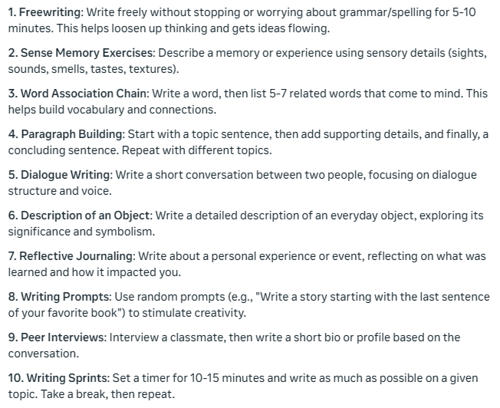

The they say/I say model of academic argumentation requires that we understand and explain other writers’ arguments before we discuss the extent to which we agree or disagree with them. Writers who skip that first step—explaining others’ arguments—end up using sources rather than responding to them.

The three ways of using the words of other writers that form the basis of source-based writing— direct quotation, paraphrase, and summary— can be thought of as three interpretive strategies. In other words, they are tools for figuring out who is saying what.

Summary writing is often part of the behind-the-scenes preparation that goes into developing a researched-argument essay. It can also be an effective citation choice if a writer wants to note the significance of a work as a whole.

The value of synthesis is that it provides a deeper, more comprehensive understanding of the subject or question at issue by bringing together divergent and partial perspectives into a collective whole.

Synthesis accomplishes multiple rhetorical and intellectual purposes:

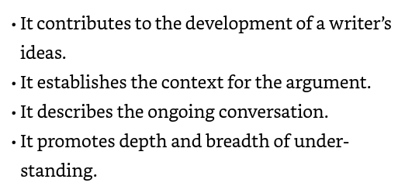

As students draft their compositions, invite them to consider the following questions: What are the relationships between your sources? What’s the relationship between your sources and your own argument?

To provide students with additional opportunities to practice paraphrasing and synthesis, consider designating a "student closer" at the end of each class. This student is responsible for summarizing the key points and insights from the day's lesson, synthesizing the main takeaways into a concise closing statement. Essentially, the "closer" provides a group paraphrase of the class meeting, offering a summary of the key points discussed. This routine also serves as a formative assessment, and it's a great way to give a student the final word.

Newcomers to academic writing often struggle to signal who is saying what. Especially when students are first learning to paraphrase, they may not clearly distinguish between their source’s voice and their own voice. For instance, in integrating someone else’s words into their own claim, students sometimes cite a source in ways that signal their agreement with a view they don’t really endorse.

Signal words and phrases such as “after all,” “indeed,” “to be sure,” “actually,” and “in fact” are clues that writers are probably speaking for themselves rather than paraphrasing the ideas of another writer.

Integrating the words of other writers into their own prose can be a challenge for students. Quotations that are less effectively integrated are signs that students need more help reading their own and others’ writing rhetorically.

Contrary views can be signaled by adding transitional phrases.

Psychologists and literary critics need different tools because they perform different tasks. APA style prioritizes the publication year because it values currency, while that of the MLA places a humanistic focus on the author. Social scientists are interested in the data; humanists are interested in the conversation.

Documentation conventions meet a real need, not just a social expectation; they help your readers engage the writers you’ve engaged.

MLA style helps you to find and understand what you want to know. It also helps you to make meaningful connections to your audience and to the academic community you’re joining.

Good writers understand why they create citations. The reasons include demonstrating the thoroughness of the writer’s research, giving credit to original sources, and ensuring that readers can find the sources consulted in order to draw their own conclusions about the writer’s argument.

A straw man is an intentional misquotation. It obscures and distorts the views of those who genuinely hold alternative perspectives by giving voice to a fictitious naysayer instead.

All writers conduct research. Whether they’re researching a historical period, an author biography, consumer reports, a contemporary issue, or a literary theory, they’re engaging in a process of discovery and integration, gathering the stuff of which texts are made.

Too often, students focus on the conventions of the genre without understanding the lengthy process of discovery and integration that produces that final piece of writing— that what they’re ultimately supposed to be writing about is all that evidence they’ve gathered and analyzed and all those observations they’ve made.

A design process flow that could be helpful in writing research documents is:

* Define the problem
* Do background research
* Specify requirements
* Brainstorm solutions
* Choose the best solution
* Do development work
* Write
* Revise and rewrite

A second way to approach the writing process is:

1. Name your topic: I am studying__________________________________,
2. Imply your question: because I want to find out who/how/why ______________________________,
3. State the rationale for the question and the project: in order to understand how/why/what ______________________________________.

Stasis theory helps us define a research problem by identifying what’s at issue for the people involved and where they’ve already found common ground. We achieve stasis when we locate that pivot point in a conversation where some people say “yes” and others say “no”.

One approach to helping students in writing research documents: first, using stasis theory, identify the kind of question each research project asks. Then, brainstorm possible exigencies for each question. Use any sources of information you have to identify urgent, real-world needs that might motivate each research question.

When it comes time for students to write about their research findings, they need to be able to establish the exigence for their line of inquiry, to say, “Here’s what happened (or is happening or might happen), and here’s why it matters.” Research that doesn’t do this fails to have a real-world impact. Some ways that students can practice finding exigencies are listed below:

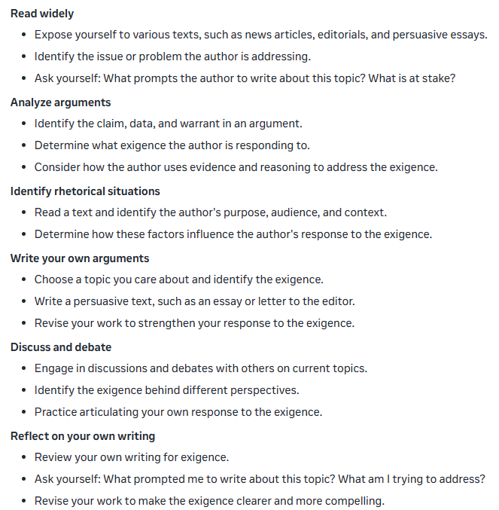

Reading, writing, experiments, interviews, observations, and discussion are all forms of data collection.

Arguments need to be about something. The better the understanding of the content, the better the argument.

Research is guided inquiry, and we’re largely guided by the other writers we read. One of the best strategies for getting unstuck in a research project is to create a reading list from the references in one of your favorite sources. As long as students have found one source they really like, they can draft off the good work of that writer by reading the sources the writer read.

Primary sources are the “raw materials” of research. Secondary sources are reports of other researchers’ findings. Whether a particular source is primary or secondary can depend on the research question.

The CRAAP test is a method for evaluating sources based on five criteria, which are as follows:

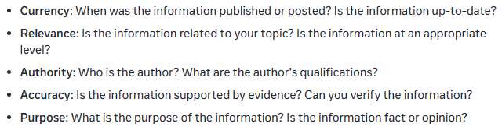

Credible sources start with scholarly search tools and solid mentor texts.

An annotated outline is a detailed outline of a writing project that includes brief notes or annotations about each section or point. It's a tool to help organize and develop ideas, and it can be especially helpful for research papers, essays, and other complex writing projects.

An annotated outline typically includes:

1. Main points or headings
2. Brief summaries or explanations of each point
3. Key terms or definitions
4. References or citations
5. Notes on supporting evidence or examples
6. Ideas for transitions or connections between points

Using an annotated outline can help in several ways:

1. Clarifies ideas: By breaking down your ideas into smaller chunks, you can see the relationships between them and how they fit together.
2. Organizes structure: An annotated outline helps you visualize the overall structure of your writing and ensures a logical flow of ideas.
3. Saves time: By planning out your writing in advance, you can avoid writer's block and reduce the need for revisions.
4. Ensures coverage: An annotated outline helps you ensure that you've covered all the necessary points and supporting evidence.
5. Facilitates research: By including references and citations, you can easily keep track of your sources and avoid plagiarism.

A draft outline is a preliminary outline of a writing project, created before starting to write the first draft. It's a rough plan that helps organize ideas, structure, and content. A draft outline can be:

* Simple: A brief list of main points or headings
* Detailed: A more comprehensive outline with subpoints and supporting ideas
* Flexible: A dynamic outline that evolves as you write and refine your ideas

Research is itself an act of integration: the bringing together of different views, data points, and methods to find a workable solution to a problem.

Evidence-based reasoning is reasoning from evidence to claims. This includes analyzing and evaluating data, unpacking assumptions (or warrants), identifying backing, drawing conclusions, and recognizing the limits of our understanding. Reasoning rhetorically means reasoning with an awareness of audience, purpose, genre, and context.

Oversimplification is the novice’s survival strategy. If we can reduce something that’s highly complex to something simple, we feel like we’ve got things under control. The problem is that we then think we understand something when we don’t. The process of reasoned inquiry can’t be reduced to a checklist or fill-in-the-blank worksheet.

1. Questioning: Identify a problem or question and ask clarifying questions to understand the issue.
2. Investigating: Gather relevant information and evidence from credible sources.
3. Analyzing: Examine the information, identify patterns, and evaluate the evidence.
4. Conceptualizing: Develop a concept or hypothesis to explain the issue.
5. Reasoning: Draw logical conclusions and make informed decisions based on the analysis.
6. Evaluating: Assess the strengths and weaknesses of your reasoning and consider alternative perspectives.
7. Revising: Refine your thinking and adjust your conclusions as needed.
8. Communicating: Share your findings and reasoning with others, using clear and effective communication.

If we’re approaching argument as inquiry, an unsupported claim is a reminder to go back and listen to the conversation more carefully and gather some more evidence. It’s not a demand to find evidence to support that specific claim.

Evidence produces and justifies a claim. Some evidence writers will generate themselves: annotations, quick-writes, observations, personal experiences. Other evidence may be gathered through a formal research process. The types of evidence and claims used and valued vary according to the rhetorical situation.

Encourage students to explain how their evidence helped them to develop their ideas.

Connections between the evidence and the claims are often underdeveloped and unarticulated. This is often a sign of an inexperienced writer conducting research.

Reasoning is pattern finding. That’s why predetermined organizational structures can sometimes limit our ability to reason through the evidence. If one schema has already been imposed on our vision, it makes it hard for us to see other possibilities. However, if students have developed multiple methods for organizing evidence, then they can look for patterns with an open and creative mind.

Novices tend to fixate on the parts of an argument rather than the process of argumentation.

Even statistics can be debatable if there is disagreement about how the numbers were reached.

Understanding warrants can help students chart the connection between evidence and claims. A warrant can be an underlying rule, definition, principle, or belief. Warrants justify how an argument moves from point to point. If an audience wants to know how you reached a particular conclusion, you can trace your thinking by surfacing your warrants.

Deeper reasoning involves understanding how different assumptions lead to different conclusions.

Making our reasoning visible can often strengthen our arguments—and help newcomers to academic argumentation develop reasoning skills—but the necessity and effectiveness of clearly calling out a warrant depends on what the audience values and believes.

Toulmin's model of argumentation breaks arguments down into six component parts:

* Claim: a statement that something is so
* Data: the backing for the claim
* Warrant: the link between the claim and the grounds
* Backing: support for the warrant
* Modality: the degree of certainty employed in offering the argument
* Rebuttal: exceptions to the initial claim
* Toulmin’s model of argumentation is particularly valuable for college students because it provides a structured framework for analyzing and constructing arguments, skills that are essential across various academic disciplines and real-world situations

Backing refers to a type of reasoning or thinking specific to a particular context. The authors of Argumentation and Critical Decision Making define backing as “any support (specific instances, statistics, testimony, values, or credibility) that provides more specific data for the grounds or warrant”.

Backing isn’t just needed for persuading resistant audiences; it represents the expert knowledge needed to solve problems effectively. Deep, context-specific learning is going to get you closer to a solution than just a lightly held opinion.

Deep learning includes understanding how knowledge is produced, validated, disseminated, challenged, and changed.

The following template is helpful for students to surface backing information:

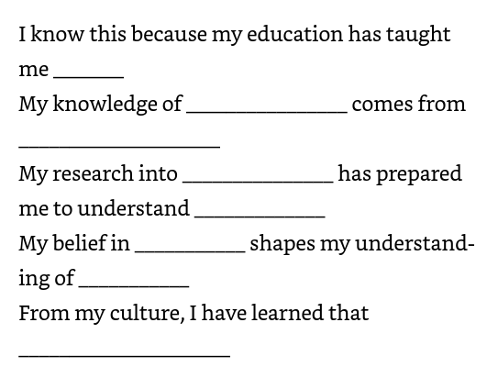

Elaboration isn’t just adding an extra sentence or two of commentary; it’s developing a carefully considered chain of reasoning.

In revising claims, a good starting place is to look for inconsistencies between evidence and assertions.

A qualifier signals how far we are willing to commit ourselves to a claim. If we qualify our claims, the thinking goes, we can lower the burden of proof. But there’s another way to approach qualification that has greater value for students’ future lives. Instead of thinking of qualification as a defensive strategy, we can view it as an invitation for others to share their expertise.

Novices tend to interpret the recommendation to limit or qualify a claim as “be specific”—an interpretation that stops short of the heightened self-awareness and reflection we’re seeking in teaching students to think critically about the social construction of knowledge.

The goals of a rhetorical approach are growth and agency. The goal of a prescriptive approach is compliance.

Transitions such as “therefore” or “consequently” raise the bar for substantiating a claim. If a student asserts that something happens “as a result” or “in consequence” of something else, they need to provide convincing support. The following transitions, or signal words, call for a high degree of certainty on the part of the writer:

* It follows
* Thus
* As a result
* Consequently
* Therefore
* In consequence

Knowing what genre and structure choices to make at the appropriate time depends on an informed understanding of the choices target audiences find most appropriate and compelling.

The actual writing that goes on in typical classrooms across the United States remains dominated by tasks in which the teacher does all the composing, and students are left only to fill in missing information, whether copying directly from a teacher’s presentation, completing worksheets and chapter summaries, replicating highly formulaic essay structures keyed to high-stakes tests, or writing to “show they know” the particular information the teacher is seeking.

The diagram below is a helpful tool for helping students to create a graphical representation regarding rhetorical decision making.

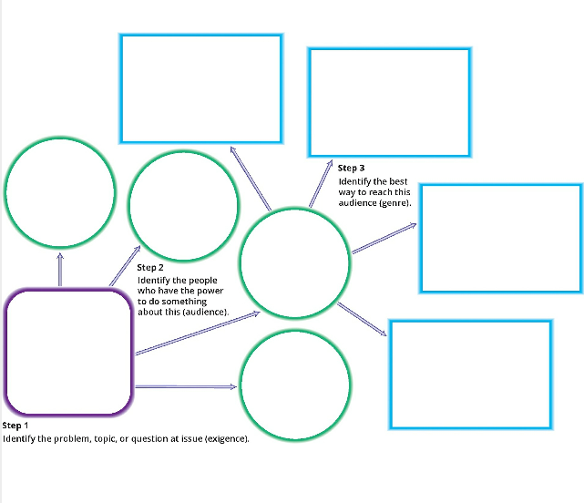

Reader-based writing is user friendly; it privileges the reader’s experience of the text above the writer’s need to complete the task.

Genres document the ways people have chosen to communicate with each other in particular settings for particular purposes.

Sometimes the discourse community we’re engaging has already made most of the decisions for us, and, unless we know how to break new rhetorical ground in that field, we’re probably going to have to follow the established genre conventions.

Making informed choices about genre requires paying attention to the conventions readers rely on as they construct meaning from a text.

Descriptive outlining, or what some teachers may call “chunking” or “charting the text,” creates a structural map of what each section of a text both says and does

Descriptive outlining is a technique used in rhetorical writing to create a detailed and organized plan for an essay or text.

1. Identify the purpose: Determine the purpose of your writing and the audience you're addressing.
2. Brainstorm topics: Generate ideas related to your purpose and audience.
3. Create a thesis statement: Develop a clear and concise thesis statement that summarizes your main argument.
4. Develop main points: Identify the main points that support your thesis statement.
5. Use descriptive phrases: Instead of using generic labels (e.g., "Point 1," "Point 2"), create descriptive phrases that summarize each main point (e.g., "The Impact of Social Media on Mental Health," "The Role of Government in Regulating Technology").
6. Add subpoints: Break down each main point into subpoints that provide more detail and supporting evidence.
7. Use rhetorical strategies: Identify opportunities to use rhetorical strategies such as ethos, pathos, and logos to persuade your audience.
8. Organize and refine: Organize your outline in a logical order and refine it to ensure clarity and coherence.

Remember, descriptive outlining looks at what writers are trying to do in each functional chunk in a composition.

Paragraph length must be managed rhetorically as part of the negotiation between writer’s needs and reader’s needs.

One of the strategies used to promote rhetorical decision making is to have students collaboratively write the opening sentence of a text for a particular rhetorical situation, such as a cover letter for a scholarship application.

Some questions that individuals use to help them write conclusions for presentations are also applicable for writing conclusions to a document:

* By the end of my presentation, what do I want them to have learned?
* By the end of my presentation, what do I want them to feel?
* By the end of my presentation, what do I want them to do?

Knowing how to do something is not the same as knowing why we do it. To transfer learning, we have to understand the principles behind the practice.

The OSCAR process of revision: Omit, Substitute, Combine, Add, and Rearrange.

Revision should be more than using the OSCAR process, it involves answering some important questions:

* What are you trying to accomplish?
* What does your audience care about?
* What do you notice about the style and structure of other texts in this genre?

Instead of a vague notion that revision involves cutting some things, adding some things, and changing some things, we can now talk about how to make strategic and selective communication choices in light of real situational contingencies. We can talk about the effects of those choices, including their impact on the writer’s ethos and the kind of reader-writer relationships they create. A rhetorical approach makes clear the abundant choices we have as writers and the plentiful context clues that can tell us which choices are most likely to help us achieve our aims.

Conditional knowledge is knowing when and why to do something; it’s a deep understanding of contingencies.

Memorizing the traits of “good” writing becomes an obstacle to effective communication when that understanding conflicts with the values and practices of particular discourse communities.

The extent to which any piece of advice improves writing depends on what the writer’s choices do in context and how readers value those particular moves.

A rhetorical approach to revision helps students understand that revising involves more than just fixing instructor “corrections” or completing a checklist. This approach recognizes that revision is a strategic, selective process.

A good starting point is a rhetorical analysis of a draft. This requires the writer to assess the draft based on the purpose of the writing, the message of the argument, the needs of the audience (including genre expectations), and the ethos the writer adopts.

The PAPA square is an activity used in rhetorical analysis that involves the following steps:

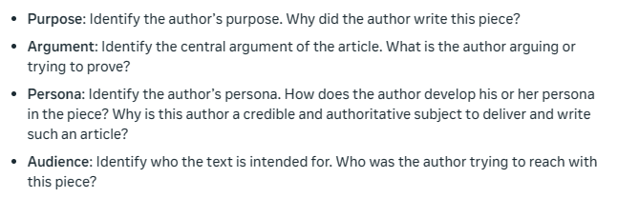

If students have also learned how to do descriptive plot outlining in their work with literary texts, they can try telling the story of their argument. Charting an argument’s dramatic arc helps students to see what they’re doing to engage their readers’ interest and keep their readers with them.

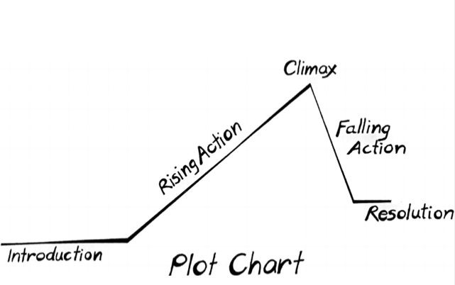

We foster rhetorical agency when we react to students’ writing as readers.

In a rhetorical approach, we take our reader feedback seriously because we care about making our writing work.

Finding the best words to describe a particular moment or effect is an exercise in critical analysis that can help students take their writing to the next level.

Sometimes we need to take something off our reader’s plate, so that the special moments we’ve created can shine. A section identified as doing less important work for the writer might be a good accessory to leave out.

Highlighting quote-worthy lines can also reveal dead zones—passages of an essay without quote-worthy material. These are probably the same sections a writer would want to leave out of an oral presentation. If your students notice dead zones, ask them if there’s anything they can do to add some pith to these problem areas.

All writing is an opportunity for students to develop persistence, flexibility, and problem-solving skills.

Encouraging students to resubmit revised work supports their growth as writers and rhetorical thinkers.

Logos means, quite simply, articulate speech. Clarity is your first duty because without it the listener cannot even offer you that most elementary of courtesies, the honor of disagreement.

Nearly anything you write can be improved. When preparing an essay or a speech expect to compose at least three drafts. Each time you comb through your text omit words that either are unnecessary or could be replaced by a word that is more precise. Here are common phrases that can be reduced:

|  |  |
| --- | --- |
| **Original Term** | **Reduced Term** |
| She is a lady who…. | She |
| Owing to the fact that… | Since |
| In spite of the fact that… | Although |
| There is no question that… | Certainly |
| No minors will be able to… | No Minors can |
| The man, who is his father, likes… | His father likes |

The passive voice works well when anonymity is desired.

One of the biggest problems with using passive voice is that it requires more words, thus it lacks concision:

|  |  |
| --- | --- |
| **Passive Voice** | **Active Voice** |
| He was hit by the ball… | The ball hit him |
| The red oak was made extinct… | The red oak vanished |
| She was awakened by the birds… | The birds woke her |

Using parallel structure in writing creates balance, clarity, and rhythm, making your writing more engaging and effective. It highlights relationships between ideas, shows careful planning, and adds emphasis and impact, making your writing more memorable and persuasive. By using parallel structure, you can communicate your ideas more clearly and efficiently, and create a more enjoyable reading experience.

These three acts of the mind are the fundamental processes of logical thinking, and they form the basis of logical reasoning and argumentation.

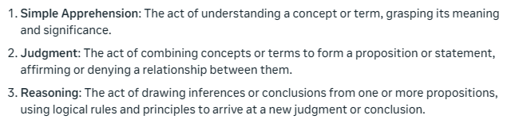

By understanding, logicians refer to the mind’s grasp of an essence or form. Form is to mark the essence or essential shape of a given thing.

Judging refers to the evaluation of the truth or falsity of a proposition.

The subject denotes what you wish to speak about; the predicate qualifies or adds to it. Below are some examples of sentence subjects in italic, and sentence predicates in bold.

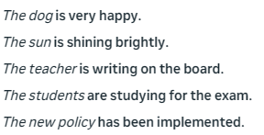

In the act of reasoning the mind posits causal links between terms and objects. In this third act of the mind, we move beyond mere observation and verbal clarification to science.

Truth is the correspondence between mind and reality and applies to propositions. Validity refers to the formal relationship between propositions.

The word fallacy comes from the Latin “fallo”, to fall or to deceive. A fallacy is an argument that appears to be valid but is not.

An amphiboly is when an entire phrase has more than one plausible meaning.

To equivocate is to conceal that you have used the same word first in one sense and then in another.

For the rhetorician, as for the logician, the first rule of clear speaking is that you define your terms—unless you have reason not to.

An error of judgment is a mistake not about terms but about natures. It is easy to assume connections between things, even when no connection exists.

Any time we presume without justification that “x” caused “y”; we commit the fallacy of false cause.

"Post hoc ergo propter hoc" is a logical fallacy where someone assumes that because event “B” followed event “A”, event “A” caused event “B”. This is a mistake, as correlation does not necessarily mean causation.

An "ad hominem" attack is a fallacy where someone criticizes the person making an argument rather than addressing the argument itself. It's a personal attack aimed at discrediting the opponent, rather than refuting their argument. This fallacy targets the person's character, traits, or beliefs, and is a mistake in reasoning that can undermine constructive dialogue and critical thinking.

An "ad populum" fallacy is an argument that relies on popular opinion or emotion rather than logical evidence or reason. It assumes that because many people believe something, it must be true. This fallacy uses phrases like "everyone knows" or "most people believe" to support an argument, rather than using sound reasoning or evidence. It's a mistake in reasoning that can lead to misleading conclusions.

No matter what the crowds say: evaluate the argument, not the speaker.

Pathos refers to the emotional quality of your presentation.

The problem with too little pathos is that it causes you to be ignored. The problem with too much emotion is that it can cause you to be despised.

Proportio is a rhetorical technique that creates balance and harmony in language by carefully arranging words, phrases, and ideas to produce a sense of rhythm and flow. This makes writing and speaking more effective, engaging, and enjoyable to experience.

To convince your listener of what you think you must first feel what you say.

In rhetoric, ethos refers to a speaker or writer's character and credibility, used to build trust and persuade an audience. It's about establishing authority and reliability, and is a key element of effective persuasion.

Decisions repeated form a habit; the sum of your habits adds up to the value of your character. A virtue is a habit of excellence. It is a tendency that perfects some part of your nature; repeated, it makes you stronger, more what you ought to be.

Credible ethos—in other words, good character—shines not only through the order of your speech, but also through the vivid motions of your body. Learn to speak with it. The language of your body will tell your audience whether or not what you say is credible. Before they listen to you, people will watch to see if you are telling them the truth.

There are three basic types of bodily motion: change of position; change of motion; change of velocity.

A moderate volume, pace, and pitch is typical of conversational speech. This is the norm against which listeners will judge you. Any variation from conversational speech will communicate emphasis.

In rhetorical writing or speaking, your aim will be to inform, to give delight, or to incite action. Of these three aims teaching is the most important. The first step is to make concrete the implication of your claims. Say directly what you wish them to do.

Once you’ve established your end—whether you wish primarily to teach, please, or move—you can turn to technique. To match means to ends, pay your respects to what is called the “communication triangle.” It’s a device for clarifying your end (and hence determining your methods or rhetorical techniques) based on an observation that goes back to Aristotle’s Rhetoric.

To specify the end or objectives of the talk, consider these “pylons” or points of the triangle within which you must work: the authority you carry as speaker, the message within your general subject, as well as the expectations of your hearers. The degree of rhetorical flourish you employ, will be determined not only by the proximate aim of your allocution (to teach, to delight, or to move), but also its subject matter (economy, war, heaven), and your position (teacher, politician, preacher). Your task is to judge how close to each of the pylons you will stand.

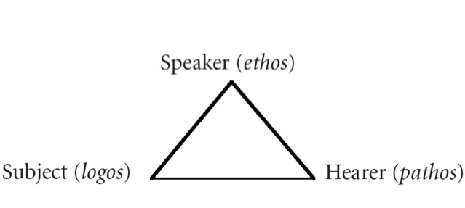

In an approximate way, these three levels of oratory relate to the points of the communication triangle. Consider the following rough guide:

|  |  |  |  |
| --- | --- | --- | --- |
| **Subject & Object +** | **Level +** | **Hearer=** | **Speaker’s Aim** |
| Academic Topics | Private | To Teach | Restrained |
| Theoretical or Practical | Semi-Public | To Please | Mixed |
| Practical Matters | Public | To Move | Grand |

Your ingenuity and your sweat do count. But to persuade others, you must learn to submit yourself—your ambitions, your personality—to the purpose of your talk.

A good essay is like a good pair of glasses. It aims not to be seen, but to make clear.

An essay will have three phases: the introduction, the body, and the conclusion.

The purpose of the introduction is to convince your reader (or listener) to keep going. If you fail at this, you succeed at nothing.

Some ways to open an essay may be:

* A surprising statistic
* A question
* An anecdote

The absence of a formal introduction can, on rare occasions, grab your reader’s attention.

The body of your paper is a whole divided by logical parts. This is where you convincingly develop your case. Each paragraph (or group of paragraphs) should advance a claim, and each claim should support your thesis. It is in the body of the essay that you offer your evidence, your examples, your illustrations; where you identify possible applications of your thesis, and sometimes raise and answer objections. Transitions mark each part.

Paragraphs may be started off by:

* A question, or an answer to a question
* Summation of the last topic and introduction to the new information
* (If the order of the document follows temporal format) Time units such as days or years
* Using an acronym (a word formed from the first letters of a phrase or name)

For concluding paragraphs, the author should:

* Restate the main idea: Briefly rephrase the thesis statement or main argument
* Summarize key points: Quickly review the main points made in the text
* Emphasize significance: Highlight the importance or implications of the argument or findings
* Provide a final thought: Offer a concluding insight, call to action, or suggestion for future exploration
* End with a strong statement: Leave the reader with something to think about or a lasting impression

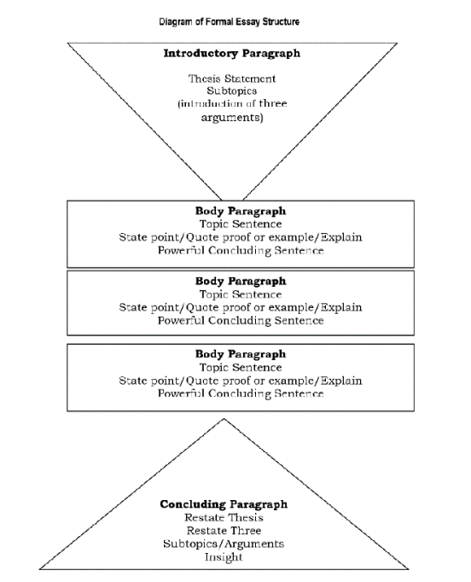

Tell a story, draw a moral. Or, ask a question, and give an answer. This format draws the listener directly into conversation. It is simplest because it most nearly imitates casual speech. You begin with a tale or a problem, and then unravel it.

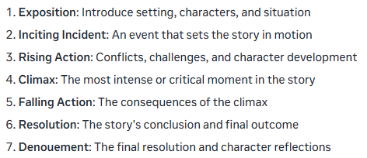

The four virtues of scholastic disputation are:

1. Obstinacy: This refers to the ability to withstand opposing arguments and maintain one's position in the face of adversity.
2. Calliditas: This refers to the ability to use clever and subtle arguments to defend one's position.
3. Sollertia: This refers to the ability to quickly think of arguments and respond to opposing views.
4. Veementia: This refers to the ability to argue with great passion and conviction.

Literary figures, also known as rhetorical devices or figures of speech, are techniques used in writing and speech to convey meaning, create tone, and persuade audiences. They are used to add depth, complexity, and style to language, making it more engaging, memorable, and effective. Some are listed below:

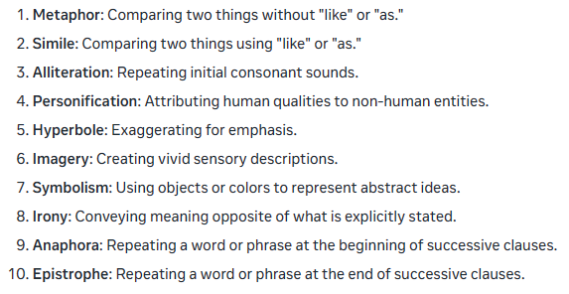

Sometimes people think that informal speeches don’t require preparation. That is a mistake. In fact, they often require more work. The less time you have to make your point, the more precise you need to be. In light of this, bring notes at first. Silly and entertaining talks benefit from this discipline as much as do formal presentations.

Before you arrive for a speech, or begin writing, clarify your disposition. You can do this by reviewing a few basic questions.

* What do you wish to accomplish?
* Do you wish to teach (what?), please (how?), move (where?)?